OLA Annual Reports 2022-23
Divisions, Committees, Round Tables, Special Assignments
As of 11/24/23

OLA unit: Academic Division
Name: Kirsten Hostetler
Work or Primary Email: acrlor@olaweb.org
Division, RT, Committee Board Members
Carly Lamphere, President elect; Emily Ford, past president; Amy Stewart, private colleges rep; Dwight Mears, legislative rep; Tamara Ottum, State Library rep; Justine Munds, community college rep; Margaret Alexander, public universities rep; Max H. Robinson, member at large; Katie Williams, member at large; and Jessica Nichols, communications

Overall Goals & Responsibilities
The Academic Division of OLA serves a dual role as the Oregon chapter of the Association of College and Research Libraries (ACRL). The Academic Division/ACRL-OR seeks to foster communication among academic library personnel; to promote the development of Oregon's academic libraries; to sponsor educational programs of interest to academic library personnel; to serve as liaison between academic personnel and various other academic and library constituencies; and to advocate for academic libraries and library personnel on the state level.
Stories -
The board rallied in support of our Linn Benton Community College colleagues when it was announced that all instructional librarians would be dismissed at the end of the academic year. The board quickly approved a letter sent to LBCC president and board of directors, and we individually wrote letters as well.

Successes - highlights annual achievements to celebrate.
Pivoted to online conference due to low turn-out for in-person joint conference with ACRL-WA in Menucha. The online conference was well attended, including the social hour

Challenges - lists ongoing challenges open for discussion — suggest solutions.
While the pivot to online was a success, the need to do so as a result of low registration numbers was a disappointment. Going forward, the board is looking at more attractive ways to host an in-person conference, including moving forward as a pre-conference to OLA or hosting a one day offering in an academic library.

General Updates - include updates that do not fit in other categories.
Focus Areas
Focus 1 EDI and Antiracism: Actively commit to being an equitable, diverse, inclusive, and anti-racist organization. List project status in this area. Include progress toward goals and objectives from the strategic plan if applicable.
Continue to offer webinars highlighting EDI Efforts, including co-sponsoring ILAGO's keynote speaker on critical information literacy. Offering professional development funds to those who pursue EDI Trainings. Recognize work from colleagues as part of our Award for Excellence.

Focus 2 Advocacy: Strengthen OLA’s leadership and advocacy role across the state. List project status in this area. Include progress toward goals and objectives from the strategic plan if applicable.
Wrote advocacy letter in support of our colleagues at Linn Benton and University of Washington librarians.

Focus 3 Membership: Increase engagement in OLA and enrich the membership experience. List project status in this area. Include progress toward goals and objectives from the strategic plan if applicable.
Offered social events and additional online professional development opportunities throughout the year.

Other comments

OLA Annual Reports 2022-23
Divisions, Committees, Round Tables, Special Assignments
OLA unit: Children's Services Division
Name: Tara Morissette and Emily West, co-chairs
Work or Primary Email: csd@olaweb.org
Division, RT, Committee Board Members
Board Members: Susan Cackler, Emily West, Tara Morissette, Monica Hoffman, Alec Chunn, Holly Campbell-Polivka, Anna Bruce, Jaime Thoreson, Deborah VanDetta, Jennifer Knight, Jane Corry, Aurora Ropp, and Amy Forrester.Lampman Committee members: Holly Campbell-Polivka, Jennifer Fischer, Darcy Smith, Amanda Lamb, Deborah VanDetta, and Susan Cackler.Scholarship Committee members: Deborah VanDetta, Tara Morissette, and Emily West.

Overall Goals & Responsibilities
CSD champions children’s literacy and provides continuing education for Oregon library staff serving children and families. Our goals are to promote the joy of reading; participate in conversations with families, community organizations, and stakeholders to provide subject matter expertise; and to provide opportunities for peer collaboration and resource sharing.
Stories - stories highlighting annual member or committee successes and challenges.
At the Lampman Award ceremony celebrating Rocío Espinoza-Cotero, Holly Campbell-Polivka had the pleasure of driving a paper Library on the Loose van from table to table while people at each table read direct quotes from nomination letters such as: “Rocío is a connector, cares deeply for her community, supports her coworkers, volunteers, interns, and truly everyone. "Lots of books and ideas and a few questions were shared at the Book Buzz workshop. For a complete list of books shared by people before the workshop, check out: Book Buzz: New and Noteworthy Books 2022 https://docs.google.com/spreadsheets/d/1yOtC-HuFlBWD13M93eROjM4jqX6pbb_AmVRNrvw6pT4/edit#gid=697051900 . We also shared our favorite new readalouds: https://wccls.bibliocommons.com/list/share/1353321673/2252448458 and graphic novels: https://wccls.bibliocommons.com/list/share/1353321673/2252463739.

Successes - highlights annual achievements to celebrate.
Launched the Oregon Library Presenters’ Directory. The Oregon Library Presenters’ Directory is a database of artists, educators, and presenters for Oregon library audiences. The database can be accessed year-round and replaces the bi-yearly Performers Showcase event. Our fall workshop introduced the database to the youth library community. At this meetup, Jaime Thoreson and Anna Bruce walked attendees through the information in the directory. Attendees shared their favorite presenters and connected with other library workers who were planning programs.CSD sponsored pre-conference provided a valuable training opportunity for school and public librarians to learn more about Tribal History/Shared History Curriculum and to think about how they can positively support and work with Oregon Tribes.

Challenges - lists ongoing challenges open for discussion — suggest solutions.
Since the pandemic, there are many more online learning opportunities for youth library workers. How can the Children’s Services Division contribute to learning for library workers in a meaningful way? We did not give people enough time to plan and prepare for the Spring Workshop. Also, with the OLA conference around the corner, maybe people did not want to take time for this training. So, we decided to move the workshop to Fall 2023.

General Updates - include updates that do not fit in other categories.
Our annual book auction fundraiser was a huge success. Our Chair-Elect spent many hours creating bundles of books, placing them online with photos of each book and ensuring that the books were provided to their new owners. This year’s auction raised the largest amount of money in the history of CSD. The Children’s Services Division presented a virtual workshop, “Programming Meetup: How is it Going? What's Next?” in November 2022. Rocío Espinoza-Cotero was our 2023 Evelyn Sibley Lampman Award recipient for her significant contribution to the children of Oregon. The Evelyn Sibley Lampman Award is presented annually by the Children's Services Division and is given in memory of Evelyn Sibley Lampman (1907-1980). CSD sponsored a pre-conference at the OLA conference. Oregon Library Presenters Directory Poster Session at the OLA conference. CSD Booth at the OLA conference had fun activities and prizes: Network: slap bracelet activity / Learn: what CSD does / Share: craft recipe cards / Engage: find out what an enriching opportunity it is to become a CSD board member /Have fun: create a blossoming friendship tree craft / Win: Prizes galore

Focus Areas
Focus 1 EDI and Antiracism: Actively commit to being an equitable, diverse, inclusive, and anti-racist organization. List project status in this area. Include progress toward goals and objectives from the strategic plan if applicable.
Held our workshops and board meetings virtually as a way to give access to library workers around the state of Oregon. In the Book Buzz workshop, we encouraged attendees to list their recommended reading selections using a diversity lens. At the workshop, we recommended books with diverse characters and diverse authors first. In awarding the CSD scholarships, the highest preference was given to:1. Applicants from diverse cultural/ethnic backgrounds and/or historically marginalized groups,2. Applicants employed at institutions or in positions serving under-represented groups, (Like, for example, our for Hispanic serving institutions in Oregon), Lampman Award was awarded to a person of color for the 2nd (or 3rd?) time in 40 years. Lampman Award committee for 2023-24 will include people of color for the first time ever! CSD sponsored pre-conference provided a valuable training opportunity for school and public librarians to learn more about Tribal History/Shared History Curriculum and to think about how they can positively support and work with Oregon Tribes.

Focus 2 Advocacy: Strengthen OLA’s leadership and advocacy role across the state. List project status in this area. Include progress toward goals and objectives from the strategic plan if applicable.
Recruited a full board of volunteers for 2023-24 for the first time in over five years. Two board members represented CSD at Legislative Day. CSD paid for three full scholarships and one partial scholarship to attend the 2023 OLA conference.
Focus 3 Membership: Increase engagement in OLA and enrich the membership experience. List project status in this area. Include progress toward goals and objectives from the strategic plan if applicable.
Used different communication tools (OLA Hotline, Libs-OR, Kids-Lib, Social Media, MemberClicks/Personify) to inform youth library workers about how the CSD can serve their needs. At the OLA conference, offered a networking game to help OLA attendees connect with each other in a fun and engaging way. The game was very popular and was well received.
Other comments
The CSD theme for 2022-2023 was reboot, regrowth, and reconnection.
OLA Annual Reports 2021-23
Divisions, Committees, Round Tables, Special Assignments
OLA unit: Oregon Association of School Libraries (OASL)
Name: Ayn Frazee
Work or Primary Email: oaslpresident@oasl.olaweb.org
Division, RT, Committee Board Members

Overall Goals & Responsibilities
Our mission is: To provide leadership to ensure that Oregon students and educators are effective users of ideas and information, and to pursue excellence in school library media programs. Our Purpose is: Empowering Oregon students by supporting school libraries.
Stories - stories highlighting annual member or committee successes and challenges.
Successes - highlights annual achievements to celebrate.

Challenges - lists ongoing challenges open for discussion — suggest solutions.

General Updates - include updates that do not fit in other categories.
Focus Areas
Focus 1 EDI and Antiracism: Actively commit to being an equitable, diverse, inclusive, and anti-racist organization. List project status in this area. Include progress toward goals and objectives from the strategic plan if applicable.
Focus 2 Advocacy: Strengthen OLA’s leadership and advocacy role across the state. List project status in this area. Include progress toward goals and objectives from the strategic plan if applicable.
Focus 3 Membership: Increase engagement in OLA and enrich the membership experience. List project status in this area. Include progress toward goals and objectives from the strategic plan if applicable.
Other comments

OLA Annual Reports 2022-23
Divisions, Committees, Round Tables, Special Assignments
OLA unit: Oregon Young Adult Network (OYAN)
Name: Caitlin Mcmahan
Work or Primary Email: cmcmahan@eugene-or.gov
Division, RT, Committee Board Members
Chair - Caitlin McMahan Out-going Chair - Denise Auld Incoming chair(s) - Mark Richardson & Ian Duncanson Secretary - Victoria Kromer Web Editor - Sonja Somerville Publication Manager - Katie Fischer Summer Reading Representative - Lisa Elliott
Overall Goals & Responsibilities
OYAN exists to provide a network for communications and growth among people who provide library services to teens, to increase awareness of teen library services in the state of Oregon, and to promote cooperation between school and public libraries.
Stories - stories highlighting annual member or committee successes and challenges.
This year we returned to in-person quarterly meetings, the first of which was held at the Salem Public Library. OYAN members were able to visit the newly remodeled teen area and we had guest presenters from the Salem-Keizer school district share their experiences with book challenges in their district.
Successes - highlights annual achievements to celebrate.
We had a very successful OYAN raffle at the 2023 OLA Conference! We were also able to sponsor a number of OLA presentations. I would also could our renewed in-person meetings as our biggest success!

Challenges - lists ongoing challenges open for discussion — suggest solutions.
One of the challenges that we faced the most is lack of member involvement in OYAN. During the pandemic I think many divisions suffered. People switched jobs, connections were lost, and there was a general sense of burnout. We are slowly starting to explore options to reengage OYAN members. Ideas that have been discussed are regional pods that meet outside of our quarterly meetings, including more educational presentations at quarterly member meetings, and continued engagement at the OLA conference.

General Updates - include updates that do not fit in other categories.
OYAN has also identified that we need to update our processes and even some of our job descriptions. These changes will be implemented in the 23-24 calendar year.
Focus Areas
Focus 1 EDI and Antiracism: Actively commit to being an equitable, diverse, inclusive, and anti-racist organization. List project status in this area. Include progress toward goals and objectives from the strategic plan if applicable.
As of the 22-23 OYAN year, our division did not have any specific language around our commitment to EDIA in our division's mission or vision. The hope is that in the 23-24 year we are able to craft language that expresses OYAN commitment to EDIA work for both members and the patrons we serve.

Focus 2 Advocacy: Strengthen OLA’s leadership and advocacy role across the state. List project status in this area. Include progress toward goals and objectives from the strategic plan if applicable.
We are hoping to create an environment within OYAN that encourages members (and non-members) to take on leadership roles within OLA, but also provide supportive structure around OYAN leadership roles. Some of these strategies are to make more of the officer positions co-chair positions, exploring volunteer opportunities for OYAN members, and more general structure around officer titles and responsibilities. Again, these official changes will take place in the 23-24 year.
Focus 3 Membership: Increase engagement in OLA and enrich the membership experience. List project status in this area. Include progress toward goals and objectives from the strategic plan if applicable.
Our biggest initiative towards increasing membership is the introduction of regional pods in 23-24. We are hoping that, by supporting smaller scale, regional meetings, OYAN members and prospective members will feel an increased sense of community and have a feeling of comradery within the great OYAN structure. We plan to incorporate pod meetings into the quarterly OYAN meetings as well. We have also decided to create a division Instagram rather than using Facebook as our primary social media tool.

Other comments
The 22-23 was a big year of assessment and planning. It will take a number of years to build up OYAN to where we want it to be, but we're hoping that the assessments and planning of 22-23 will create a solid foundation for the years to come.

OLA Annual Reports 2022-23
Divisions, Committees, Round Tables, Special Assignments
OLA unit: Public Library Division (PLD)
Name: Haley Lagasse
Work or Primary Email: pld@olaweb.org
Division, RT, Committee Board Members
Chair - Haley Lagasse; Vice Chair / Chair Elect - Megan Dazey; Secretary - Chris Myers (2021-2023); Past Chair - Halsted Bernard; Member-at-Large #1 - Beka Murcray (2021-2023); Member-at-Large #2 - Greg Williams (2021-2023); Member-at-Large #3 - Molly Carlise (2022-2024); Member-at-Large #4 - Sami Pierson (2022-2024)

Overall Goals & Responsibilities
The purpose of the Public Library Division is to promote public library service and development, to promote the potential for increasing cooperation among public libraries, to represent the interests and concerns of public libraries in relation to the Oregon Library Association and the Oregon State Library, and to develop legislative priorities for public libraries and other issues as may be pertinent to the Division.
Stories - stories highlighting annual member or committee successes and challenges.
This year included several meaningful and important milestones for the division. First, the division drafted and adopted its first-ever annual budget. This process brings transparency to the division's resources and informed a number of important board decisions this year. The division hosted its first major fundraising event (that any currently involved can remember), creating a virtual wellness challenge called Expedition Happy. Over 40 people participated in this virtual race around Oregon, visiting public libraries and logging independent wellness activities, from walking to reading to napping.
Successes - highlights annual achievements to celebrate.
from around the state joined in the multi-week challenge, logging a variety of wellness activities along a virtual route visiting public libraries across Oregon. The event culminated with honoring participants at the division's OLA Conference Opening Reception. The reception was a great event with a packed room, lots of good food and conversation, and an opportunity to reconnect with colleagues. At the reception we also honored Dea Nowell of the Umatilla County Special Library District, winner of this year's Pearl Award.In March, the division hosted an UnConference at the Tigard Public Library. The event was well attended by a diverse group of library staff. The event included a talk by Meredith Farkas titled "Ten Toxic Ideas that Need to Die for a Better Collective Future" followed by a series of round table discussions on topics selected by attendees.

Challenges - lists ongoing challenges open for discussion — suggest solutions.
The division continues to struggle with workload versus capacity issues. We have experienced a small decline in membership and it has been a challenge to recruit new board members in recent years. We have found that people are interested in attending events like our UnConference, but do not have the capacity in their work lives to take on volunteer responsibilities for the division. Our existing volunteer board has great ideas and many worthwhile projects to pursue but we have limited capacity to do so. The Board has considered compiling a list of short-term or clearly time-limited volunteer opportunities that would be shared with the full division membership to recruit additional participation.

General Updates - include updates that do not fit in other categories.
The Public Library Standards are an on-going division project. For the last year, the Public Library Standards Committee has been pursuing a full review of the Standards using cultural competency and humility lenses. As with the division as a whole, it has been difficult to recruit volunteers to serve on this committee and our review has had several starts and stops. The outgoing division chair will serve as the facilitator for the committee this fall, and the group has begun meeting on a regular basis again. The committee is planning a series of online community input meetings in the fall to provide the broader library community the opportunity to submit feedback and questions about the Standards.

Focus Areas
Focus 1 EDI and Antiracism: Actively commit to being an equitable, diverse, inclusive, and anti-racist organization. List project status in this area. Include progress toward goals and objectives from the strategic plan if applicable.
EDI and Antiracism were integrated into the round-table discussions at our spring UnConference, in discussions about hiring and retaining employees, determining what public services are needed in an individual community and self-care. The UnConference talk on toxic workplaces also included resources on these topics. The Public Library Standards Committee has engaged with the EDIA Committee and REFORMA regarding their planned cultural competency review.

Focus 2 Advocacy: Strengthen OLA’s leadership and advocacy role across the state. List project status in this area. Include progress toward goals and objectives from the strategic plan if applicable.
The Board has discussed planning future public library directors' meetings to coincide with legislative day, as in the past.

Focus 3 Membership: Increase engagement in OLA and enrich the membership experience. List project status in this area. Include progress toward goals and objectives from the strategic plan if applicable.
The division hosted a reception at the OLA Conference, providing the opportunity for people to connect. The Expedition Happy challenge also supports engagement.

Other comments

OLA Annual Reports 2022-23
Divisions, Committees, Round Tables, Special Assignments

OLA unit: REFORMA Oregon
Name: Brandace Rojo
Work or Primary Email: brojo@JosephineLibary.org
Division, RT, Committee Board Members
Overall Goals & Responsibilities
Stories - stories highlighting annual member or committee successes and challenges.
Successes - highlights annual achievements to celebrate.

Challenges - lists ongoing challenges open for discussion — suggest solutions.

General Updates - includes updates that do not fit in other categories.
Focus Areas
Focus 1 EDI and Antiracism: Actively commit to being an equitable, diverse, inclusive, and anti-racist organization. List project status in this area. Include progress toward goals and objectives from the strategic plan if applicable.

Focus 2 Advocacy: Strengthen OLA’s leadership and advocacy role across the state. List project status in this area. Include progress toward goals and objectives from the strategic plan if applicable.
Focus 3 Membership: Increase engagement in OLA and enrich the membership experience. List project status in this area. Include progress toward goals and objectives from the strategic plan if applicable
Other comments

OLA Annual Reports 2022-223
Divisions, Committees, Round Tables, Special Assignments

OLA unit: Support Staff Division (SSD)
Name: Rinny Lakin
Work or Primary Email: ssd@olaweb.org
Division, RT, Committee Board Members
Rinny Lakin, Chair; Jordan Popoff, Treasurer; Chelsey Comstock, Secretary; Deanna Kohn, Archivist/Continuing Education Committee; Sara Trott, Digital Media Specialist; Eufrosina Cervantes Santos, Member at Large; Paula Jolly, Member at Large; Tru Bui, Conference Committee, Conference Tech Support; Françoise Lemieux, Conference Committee, Conference Event Photographer; Rashelle Maplethorpe and Lydia Alvarez, Conference Raffle Managers
Overall Goals & Responsibilities
The purpose of the Support Staff Division shall be to provide a framework for information sharing, continuing education and moral support for all library support staff. Specifically, the aims are to provide a forum to encourage new ideas, discuss concerns and solve problems; promote awareness of library issues; inspire and promote professional growth through networking, conferences, workshops and mentoring; exchange ideas on processes, systems, and policies; provide a medium for the exploration of new ideas and technologies; foster cooperation among all Oregon libraries in all the various public and technical areas throughout the library; and to increase awareness in the library community of the evolving roles played by support staff.
Stories - stories highlighting annual member or committee successes and challenges.
Coming off the excitement of the July 2022 SSD Conference at Timberline Lodge, we rolled right into the next year’s work in August. Starting with the OLA Board retreat, Jordan was able to attend in person at Menucha, while Rinny attended virtually.. That same week, we held the SSD Leadership retreat in beautiful Manzanita at the historic Spindrift Cottage, bringing in Eufrosina to see if SSD was where she wanted to put her energies. It was a bit chaotic having children and dogs creating static electricity around us, but we did our best!-We digested the feedback and lessons from the 2022 SSD Conference-We reviewed the Strategic Plan and had Star Khan’s vision for the year as OLA President and how SSD can align our activities with these focus areas-We did skill and group building activities from LIOLA, the EDIA Toolkit and beyond-We reviewed our Bylaws with Buzzy Nielson-We talked about issues facing libraries and staff and carried that into making big strides toward our OLA conference proposals and planning the 2023 SSD Conference. For Labor day, Paula and Jordan went to Ashland to investigate the options to bring our conference to Southern Oregon and after careful research, made a strong recommendation for Ashland Hills Hotel and Conference Center. Every monthly SSD meeting, and in between, we steadily chipped away at the many moving parts that it takes to contribute to the OLA Conference, listen to what is happening for library staff around the state and how to support them, AND develop the SSD conference. This year, we decided to try a Welcome Reception the evening before the SSD Conference in response to the request for more networking time, something we have never tried before! The team was burdened with tasks that should be spread over 10+ people. Tasks increasingly fell to a smaller and smaller handful that had any capacity at all, even though it was almost completely unpaid labor. Even so, Sara and Eufrosina went above and beyond to create a new SSD website (olassd.org) and the Personify App for the conference. In April, at the OLA Conference, several of us were privileged to attend in person in Bend.-SSD Information table (thanks Deanna and Sara!) and we had the coolest playing card (thanks Lacy!)-Book mending pre-conference with book mending kits for sale (Thanks Sara and Connie!)-Donna Cohen virtual session-Presented Margaret Harmon-Myers with the OLA Distinguished Service Award for her dedication to OLA (and SSD in particular.)In July, some of us were able to be in person to put on the SSD Welcome Social and Conference. It was a really wonderful experience to see the results of our work, and get to meet Oregon Library faces that were new to us.
Successes - highlights annual achievements to celebrate.
We were able to engage library staff in Southern Oregon with OLA and SSD for the first time in decades! The Welcome Reception was a wild success, more than we ever imagined. The feedback we received from attendees and presenters is very positive.

Challenges - lists ongoing challenges open for discussion — suggest solutions.
Library staff are struggling to get support from their employers to participate in OLA, and some libraries appear to not value the professional development of support staff. It was not a given that our own board could attend the very conference we orchestrated, and at the end of the day, two important members could not! We have become a teeny tiny group, most of us doing this work unpaid. Most of us are well past our position terms, without any clear leaders on the horizon to continue this important work. As such, we are shrinking our responsibilities for the next year. We canceled our leadership retreat and the 2024 SSD Conference to focus on rebuilding our leadership and ensuring that SSD has a strong presence at the 2024 OLA Conference.

General Updates - include updates that do not fit in other categories.
We are fortunate to have the following people tentatively continuing into the next year, well beyond the terms we all signed up for: Rinny Lakin, Chair; Jordan Popoff, Treasurer; Deanna Kohn, Archivist/Continuing Education Committee; Chelsey Comstock, Member at Large; Eufrosina Cervantes Santos, Member at Large; Tru Bui, Conference Committee, Conference Tech Support Françoise Lemieux, Conference Committee, Conference Event Photographer; Vacant: Secretary and a dozen other positions

Focus Areas
Focus 1 EDI and Antiracism: Actively commit to being an equitable, diverse, inclusive, and anti-racist organization. List project status in this area. Include progress toward goals and objectives from the strategic plan if applicable.
We were reflective of who was missing from our table, took deep dive examinations into barriers, our processes, deliverables, topics, presenters, sponsors and how we can support library staff across our state. Everything got put under a bright light and sometimes we shocked ourselves to find cockroaches skittered out. It was exhausting, but important work. We lifted up the voices of the EDIA committee supporting them to hold a voting position on the OLA Board like the Division chairs do; sharing information about the EDIA Committee and opportunities to participate and support; and their podcast. We highlighted this at our conferences, on social media, amongst our co-workers and at the SSD Information table at the OLA Conference. We are very fortunate to have had a Lightning Talk about the EDIA Committee from Ericka Brunson-Rochette and Brittany Young at the 2023 SSD Conference! We reviewed our Bylaws to make it easier for people to participate and update some language. We tried to reduce barriers to participation by allowing children at the SSD Leadership retreat, but that is a logistical puzzle we haven’t really figured out yet.

Focus 2 Advocacy: Strengthen OLA’s leadership and advocacy role across the state. List project status in this area. Include progress toward goals and objectives from the strategic plan if applicable.
Your SSD board deeply listens, advises, refers, but more than anything, empathizes. Staff struggles are brought to the unrecorded portion of the meetings, where it is safe to discuss and we are always listening for how we can support library staff. Your chair has been attending dozens of big and quiet meetings in the Portland Metro area where staff need advocacy: speaking truth to power one on one; having a library staff perspective giving input into new library designs and new processes such as automation (often where staff of that system were discouraged or not allowed); weighing in where libraries are rethinking staff roles; supporting bargaining for pay and worker rights; municipal meetings where library support is under fire; writing to legislators in Oregon, Washington and our Federal representatives. We are trying to stay ahead of library trends so staff can prepare and respond. We try to be there for staff going through trauma, loss, layoffs, and celebrating wins and retirements. The things library staff have been through this year are crushing and it’s been a roller coaster ride of emotions, but we are in this together. I believe every member of the SSD board is doing this to some degree within our sphere’s of influence. We are caring leaders no matter what our job title says. SSD has a strong voice on the OLA Board to speak to the real experiences of Oregon Library staff.
Focus 3 Membership: Increase engagement in OLA and enrich the membership experience. List project status in this area. Include progress toward goals and objectives from the strategic plan if applicable.
SSD’s main effort in this area was the 2023 SSD Conference. In addition to the attendee experience of networking and learning, we cultivated opportunities for 20 people to come to the SSD conference with a role of their own. For many, this was a new opportunity to stretch in some way that hadn’t been available to them in their library roles. The SSD Leadership retreat allowed a deeper level of meaningful engagement and membership experience for a smaller group. We are concerned about the cost of OLA Membership being a barrier. We created an opt-in mailchimp mailing list so that we could engage and update support staff without concern about the status of their OLA membership. We also offer scholarships for OLA memberships and professional development. Through a State Library of Oregon grant, we were able to support 13 scholarship applicants, 7 of which are not members of OLA.
Other comments
We are optimistic about the direction OLA is moving. There is a lot of work to be done in libraries, and we need all of us

OLA Annual Reports 2022-23
Divisions, Committees, Round Tables, Special Assignments

OLA unit: Awards Committee
Name: Elsa Loftis
Work or Primary Email: eloftis@pdx.edu

Division, RT, Committee Board Members:
Elsa Loftis, eloftis@pdx.edu (co-chair) and Karen Muller, karen.muller@hillsboro-oregon.gov (co-chair); Sonja Somerville, SSomerville@cityofsalem.net; Emily O’Neal, emilyo@dpls.lib.or.us; and Jessica Lorentz Smith, president@oasl.olaweb.org

Overall Goals & Responsibilities
The Awards Committee recognizes and honors outstanding individuals for their service to the Oregon library community.
Stories - stories highlighting annual member or committee successes and challenges.
In our first in-person awards ceremony since 2019, we were thrilled to honor our award winners at OLA Annual in Bend, Oregon! We had a wonderful slate of nominations. We awarded TWO awards for Library Supporter of the Year, and here is the local news story about the winning couple from Mt. Angel public library! https://www.woodburnindependent.com/news/mount-angel-couple-receives-2023-library-supporter-honors/article_cd0ebd52-ff39-11ed-aab2-a76ed4af6563.html

Successes - highlights annual achievements to celebrate.
Even as we were back in person, we had some hybrid content, which was new for us. Thank you to the conference organizers to make this possible!

Challenges - lists ongoing challenges open for discussion — suggest solutions.
While our winners were well-deserving and fantastic, we do hope to gather more nominations in the future. We regretfully did not receive any nominations for a Library Employee of the Year, for example. So, other than advertising on Libs-OR, the Hotline, and reaching out to unit leaders, it would be good to find further avenues to announce these nominations.

General Updates - include updates that do not fit in other categories.
Oregon Librarian of the year: Librarians and Staff of the Crook County LibraryOregon Library Supporter of the year: Karen Salman, Springfield Public Library and History MuseumOregon Library Supporter of the year: Keith and Margaret "Pepper" Teem, Mt. Angel Public LibraryEDI Achievement Award: Ericka Brunson-Rochette(not given by the Awards Committee, but the Presidents‚Äô Award goes to Roxanne Renteria, and the President's Accomplice Award goes to Arelene Weible. We will be printing, framing, and coordinating the presentation of the award). Elsa Loftis has been chair of the committee since 2019, and co-chaired with Karen Muller this past year. Elsa will step off the committee this year, so there is an open space on the committee.

Focus Areas
Focus 1 EDI and Antiracism: Actively commit to being an equitable, diverse, inclusive, and anti-racist organization. List project status in this area. Include progress toward goals and objectives from the strategic plan if applicable.
This was the third consecutive year that we have recognized antiracism work in our communities with the EDI Achievement Award, which helps to demonstrate OLA's values and mission in fostering an antiracist organization. Our intention is to continue to have at least one representative of the OLA EDI Committee on the Awards Committee.

Focus 2 Advocacy: Strengthen OLA’s leadership and advocacy role across the state. List project status in this area. Include progress toward goals and objectives from the strategic plan if applicable.
We successfully celebrated some amazing library community members, and gave them the tools (press releases) to spread the word about their achievements in their local communities.

Focus 3 Membership: Increase engagement in OLA and enrich the membership experience. List project status in this area. Include progress toward goals and objectives from the strategic plan if applicable.
We hope to find further ways to engage the OLA community to bring in more nominations for winners in the future.

Other comments

OLA Annual Reports 2022-23
Divisions, Committees, Round Tables, Special Assignments
OLA unit: Communications Committee – under reorganization during 22-23 no report
Name:
Work or Primary Email:
Division, RT, Committee Board Members

Overall Goals & Responsibilities
The OLA Communications Committee is comprised of 18 library professionals working towards creating a civil society in Oregon and beyond through library service. We publish the OLA Quarterly professional journal, the OLA Hotline blog/newsletter, and the OLA Social Media channels. We assist the OLA Board and conference committee when they need help with promotional information.
Stories - stories highlighting annual member or committee successes and challenges.
Successes - highlights annual achievements to celebrate.

Challenges - lists ongoing challenges open for discussion — suggest solutions.

General Updates - include updates that do not fit in other categories.
Focus Areas
Focus 1 EDI and Antiracism: Actively commit to being an equitable, diverse, inclusive, and anti-racist organization. List project status in this area. Include progress toward goals and objectives from the strategic plan if applicable.

Focus 2 Advocacy: Strengthen OLA’s leadership and advocacy role across the state. List project status in this area. Include progress toward goals and objectives from the strategic plan if applicable.
Focus 3 Membership: Increase engagement in OLA and enrich the membership experience. List project status in this area. Include progress toward goals and objectives from the strategic plan if applicable.
Other comments

OLA Annual Reports 2022-23
Divisions, Committees, Round Tables, Special Assignments

OLA unit: Conference Committee
Name: Liisa Sjoblom
Work or Primary Email: liisas@deschuteslibrary.org

Division, RT, Committee Board Members
Liisa Sjoblom, Chair; Stuart Levy, Treasurer; Star Khan, OLA President; Brittany Young, OLA President Elect; Kim Olson-Charles, Speaker Arrangements and Hospitality; Sonja Sommerville, Program Chair; Laura Kimberly, Poster Session Coordinator; April Witteveen, Local Arrangements; Graham Fox, Technology Coordinator; Rya Fennewald, Food Coordinator; Roxanne Renteria, Online Registration; Cathy Zgraggen, Onsite Registration; Lacey Legel, Virtual Conference Coordinator; Kathy Street, Volunteers Coordinator; Anne Campbell, Exhibits Co-Chair and Miriam Sisson, Exhibits Co-Chair; Jordan Popoff, Fundraising Coordinator; Darci Hanning, Communications; Sergio Lopez, Webmaster; Kirsten Hostetler, Printed Program Coordinator; Shirley Roberts, Association Manager

Overall Goals & Responsibilities
To plan, coordinate, promote and execute the OLA Annual Conference a fiscally responsible conference around the theme of Equity, Diversity and Inclusion. The conference committee strives to provide an annual conference that offers relevant programs, speakers, and networking opportunities for the diverse library staff from around the state. The overall goal is that every attendee will find substantive programs and current information to benefit and enhance their library work and professional development, as well as provide networking opportunities to meet and connect with library staff from around the state.
Stories - stories highlighting annual member or committee successes and challenges.
The 2023 Oregon Library Association Annual Conference, “Rekindle. Rejuvenate. Reimagine,” was held April 19-22, 2023 at the Riverhouse on the Deschutes in Bend, Oregon. This was the first in-person conference since 2019 with the added component of virtual content both recorded and live-streaming. The added complexity of doing hybrid programming along with being a bit rusty with planning led to some challenges, but the conference was generally enjoyed by all with high marks going to session content. Conference attendance exceeded expectations with 448 people attending one or more days over the four-day event. The budgeted net profit was $24,769.79 with an actual net profit of $58,498.60 according to conference budget documents. Given that there are probably some errors in the spreadsheet, the likely profit is closer to $57,500. The one negative note that we had this year was the quality of the plated meals. We had done a tasting the month previous to the conference and everything was quite tasty. Unfortunately, between the tasting and the actual conference something went awry. Portion size was very small, especially for the vegetarian options and all meals were quite bland. The good news was the all of the appetizers for the receptions were quite good. Comments on the food and facilities were shared with Riverhouse staff.. Initially we had difficulty with communication with conference center staff, but once we were assigned an Event Manager, calls and emails were responded to quickly. Generally, those calls were promptly returned. On-site during the conference, staff was very responsive and quick to assist or make adjustments as needed. When the final invoice arrived, there were a number of errors regarding rented equipment and the assignment of the free room nights. All were resolved promptly. Our biggest challenge with the Riverhouse involved room reservations. The reservation site was confusing and in January they upgraded their system and seemed to have lost some reservations. We even heard of one room being assigned to two different people with one arriving a day later than the first individual. Luckily all of these issues were dealt with quickly and everyone was assigned a room as they expected. We received over 174 conference evaluations. Comments ranged from the negative regarding confusion about the website, conference app, and meals to the very positive about programming, the ability to meet in person, and the hybrid offerings. Due to the sheer number of comments, they are not included here. Please contact Liisa Sjoblom , I f you would like to receive a copy of the compiled evaluation report. This year’s conference team did a great job of planning and executing the conference. For the most part the conference chair only needed to provide guidance to this highly motivated and skilled group of individuals from around the state. We shook things up by trying out hybrid programming, using a new conference app, moving the President’s Party (aka Library Prom) to Friday evening, a new program schedule and adding affinity group meetings.

Successes - highlights annual achievements to celebrate.
--Conference profits more than exceeded expectations.
--Higher attendance than expected.
--Thanks to Brittany and her connections with DTEN, we were able to offer livestreaming programs to virtual attendees.
--Pulled off a fairly successful hybrid conference.
--Affinity group (Public, Academic, School, Special, BIPOC) meetings were a hit. May swap out Special (basically no attendance) for LGBTQIA+ in future years.

Challenges - lists ongoing challenges open for discussion — suggest solutions.
--Putting on a hybrid conference for the first time was challenging. We learned a lot and came to the conclusion that for OLA hybrid conferences in the future should consist of pre-recorded program sessions and live-stream plenary events such as keynote and author presentations.
--Used Personify's conference app for the first time. The cost was low, but the app itself was not robust enough for our needs. The subscription will cancelled at the end of the subscription year.
--We had a very small exhibits area with only 28 vendors. We need to start the invite process earlier and follow-up more frequently with phone calls.
--The printed program was significantly delayed due to content that was not provided in a timely manner. We need to make sure that deadlines are firm and all committee members are aware of those deadlines.
--The biggest complaint was about the food at the Riverhouse. The meal quality and portion size was very surprising and not at all what we had during the tasting the month before. We are not sure what happened, but the chef was fairly new having only been hired in January. All comments were shared with Riverhouse staff in the hopes they can learn from the experience.

General Updates - include updates that do not fit in other categories.
Focus Areas
Focus 1 EDI and Antiracism: Actively commit to being an equitable, diverse, inclusive, and anti-racist organization. List project status in this area. Include progress toward goals and objectives from the strategic plan if applicable.
--Provided space for a BIPOC affinity group meeting during the conference. Plan to expand such offerings to include a LGBTQIA+ session in 2024.
--Encouraged program proposals to be inclusive and address EDIAR issues.

Focus 2 Advocacy: Strengthen OLA’s leadership and advocacy role across the state. List project status in this area. Include progress toward goals and objectives from the strategic plan if applicable.
Focus 3 Membership: Increase engagement in OLA and enrich the membership experience. List project status in this area. Include progress toward goals and objectives from the strategic plan if applicable.
--Despite some challenges in the prep work, the trading card activity was well received and engaged attendees in learning about the various OLA units.
--Committee membership had representation of all types of libraries of all sizes from across the state.
--Provided ample time for attendees from across the state to meet and network.
Other comments
Full report and conference evaluations available from Liisa Sjoblom (liisas@deschuteslibrary.org)

OLA Annual Reports 2022-23
Divisions, Committees, Round Tables, Special Assignments
OLA unit: EDI Antiracism Committee
Name: Ericka Brunson-Rochette
Work or Primary Email: erickab@deschuteslibrary.org
Division, RT, Committee Board Members
Melissa Anderson: Ericka Brunson-Rochette; Kristen Curé; LaRee Dominguez; Max Macias; Brittany Young; Roxanne M. Renteria; Bryan Miyagishima; Constance Palaia; Krista Neth. Members that left during committee year: Matthew Baiocchi (December 2022); Meredith Farkas (January 2023); Stephanie Chase (June 2023)

Overall Goals & Responsibilities
An Equity, Diversity, and Inclusion (EDI) Task Force was created at the August 2019 OLA Board meeting with the charge of developing an EDI Plan for the Association. The purpose of the EDI Plan is to affirm OLA’s commitment to EDI and set direction for OLA by identifying EDI priorities and strategies to achieve them. In April 2021 this Task Force was made an OLA Standing Committee at the OLA Annual Business Meeting, held during the OLA 2021 Virtual Conference.
Stories - stories highlighting annual member or committee successes and challenges.
•The EDIA Committee released a Statement Calling for Meaningful Support for BIPOC Library Workers in October of 2022, in response to’ ongoing violence against Black people in the United States, we, the OLA Equity, Diversity, Inclusion and Antiracism Committee, reaffirm Black Lives Matter, and that Black people and African Americans, including library patrons and workers, are living under the weight of constant violence and other forms of discrimination and oppression’.
•The EDIA Committee crafted and sent a letter condemning personnel cuts to leadership and stakeholders at Linn-Benton Community College on May 30, 2023.
•The EDIA Committee was able to provide input and feedback on the IFC’s updated General Letter/Statement of Support for libraries facing censorship concerns and attacks in May 2023.
•Committee members LaRee Dominguez, Kristen Curé, Brittany Young, and Ericka Brunson-Rochette presented for the University of New Mexico’s Health Science Library staff, students and Justice, Diversity and Inclusion Committee during one of their monthly ‘Knowledge Café” events on August 17, 2023. The topic was on the OVERDUE podcast and committee work

Successes - highlights annual achievements to celebrate.
All of the work mentioned in the above “Stories” section we consider a success. All committee members worked tirelessly to craft letters of support and advocacy, and to continue to take a collective stand against oppression in our libraries. Our two most public stances were:
•Statement Calling for Meaningful Support for BIPOC Library Workers
•A letter condemning personnel cuts at Linn-Benton Community College

OLA Conference: The EDIA committee had a presence at the OLA Annual Conference held in Bend, Oregon in March. OLA President Star gifted the committee with a banner for the committee table in exhibits, and organized a fundraiser selling paper roses and raffle donations at the President’s party with proceeds to be split between the EDIA Committee and REFORMA, Oregon. These very gracious efforts raised about $600 for the committee, which were deposited into our Enterprise account. The committee also purchased books from Hinchas Press, the publisher for the Librarians with Spines series, to raffle off at the conference for anyone who made a commitment to EDIA effort(s). Yago Cura, the founder and owner of Hinchas Press, kindly donated an additional 10 books to go towards this cause. The committee started planning efforts around the idea of creating an Empathy Installation at the conference proposed by committee member Ericka Brunson-Rochette. Due to other focus areas that needed to be prioritized, the committee decided to put this on the backburner until a future conference.

OVERDUE: Weeding Out Oppression in Libraries Podcast Secured a LSTA Grant administered through the State Library of Oregon in July of 2022 of $7500, Obtained another $7700 grant to continue work on the podcast in the 2023-2024 committee term, as well. September 2022-August 2023- 13 episodes launched (11 new episodes, two re-launches), and one recorded to launch the last day of August 2023.
Season 1 wrapped at the end of February.
Season 2 launched in March of 2023. We highlighted the voices of 22 BIPOC and/or allies in the library profession. We also started Season 2 of the podcast in March of 2023. Below is a list of all of the episodes we recorded, edited and launched with funding from this grant year, the date of release, and the topic/description and guests featured for each conversation. Downloads of episodes this grant year: 2,029
Total downloads for all episodes: 4,039
Link to episodes:https://www.buzzsprout.com/1948067/episodes
Sep 30, 2022- Episode 7: Facilitating EDI Conversations with Leah Larson, Nicole Rawlinson & Priya Charry Covers the intricacies of navigating conversations around equity, diversity and inclusion in the workplace.
Oct 31, 2022- Episode 8: Putting "Friendly Places" on the Map with Roland Barksdale-Hall, touches on forging deep community connections, confronting biases, being true to oneself, active listening and making people feel seen, and the huge impact we can have on others.
Nov 15, 2022- Episode 9: School Librarians Creating a Culture of Reading and Inclusion while Navigating Challenges with K.C. Boyd, Pia Alliende & Andy Spinks. Amid book challenges, political and cultural attempts to staunch access to books that reflect the history and lives of our youth, and funding cuts to school libraries, these courageous library heroes talk about their grit and determination to provide mirrors, inspiration, and access to information for all youth.
Nov 30, 2022- Episode 10: Libraries, Communities and Mentorship- Connecting the Dots with Loida Garcia-Febo, Highlights the importance of getting out of the library and into communities, mentoring staff, in particular nurturing Black and Indigenous People of Color (BIPOC), and equipping all with empathy to better serve library communities.
Dec 30, 2022- Episode 11: Centering Equity in Oregon Libraries with Brandace Rojo and Eduardo Arizaga. Covers centering equity work as the foundation of library work, how to begin shifting Oregon library culture to better serve diverse communities as well as how a culture shift can support library workers of color.
Jan 31, 2023- Episode 12: Librarians With Spines Part 1 with Autumn Anglin, Max Macias & Yago Cura This trio of "information agitators" share the origins of this series, the need for necessary boundary-pushing in the library profession, and the importance of having a strong support system when doing antiracism work.
Feb 15, 2023- Episode 13: Librarians with Spines, Part 2 with Autumn Anglin, Max Macias & Yago Cura
Feb 28, 2023- Episode 14: Righting Black History w/Sherry Antoine, Laurie Bridges & Diana Park These individuals discuss their work to RIGHT history by writing Black history into Wikipedia. Learn about what is happening in libraries and partner organizations to further representation of Black folx (and all Black, Indigenous, and People of Color)
Mar 31, 2023- S2; Episode1: Alternative Facts & Libraries w/ Lorraine Bannai, Jon Osaki, Jenny Silbiger Discussion about Osaki’s documentary Alternative Facts: The Lies of Executive Order 9066, and how research and libraries played important roles in exposing the truths and in bringing people together in solidarity and community.
Apr 28, 2023- S2; Episode 2: Mentoring and Developing the Profession with Tracie D. Hall (Re-release)
May 31, 2023- S2; Episode 3: BIPOC Leadership in Libraries w/Chantel Walker & Patty Wong These two dynamic leaders share challenges and successes from their own lived-experiences, as well as provide suggestions on navigating leadership and opportunities as professionals of color in predominantly white spaces.
June 30, 2023- S2, Episode 4: School Librarians Creating a Culture of Reading and Inclusion while Navigating Challenges with K.C. Boyd, Pia Alliende & Andy Spinks (Re-Release)
Jul 31, 2023- S2, Episode 5: Connecting Incarcerated Patrons to Library Services w/ Jody Redifer, Enrique Rivera & Trevor Walraven. These three individuals share their experiences, as well as provide guidance around providing access to library and information services, helping incarcerated and formerly incarcerated people with resources and readily available information that is lacking in the current justice system.

Challenges - lists ongoing challenges open for discussion — suggest solutions.
We had some internal committee challenges, in terms of aligning member’s views on overall committee focus, structure and goals. This resulted in the committee pausing project work for a couple months to redirect our focus and reestablish a collective vision. Division of work/labor continues to be difficult on a committee like this, where the demand for support is high. We are hopeful that some of this burden will be alleviated when the SLO DEI Consultant is hired and in place.

General Updates - include updates that do not fit in other categories.
Committee Members LaRee Dominguez and Roxanne M. Renteria have agreed to step up as co-chairs for the 2023-2024 committee term. The following members will be remaining on the committee for the next term, in addition to the committee welcome new committee members: LaRee Dominguez; Roxanne M. Renteria; Ericka Brunson-Rochette; Bryan Miyagishima; Constance Palaia; Brittany Young. The following members have offered to be as-needed support if or when the committee is facing something that requires additional help: Melissa Anderson; Kristen Curé; Max Macias; Bryan Miyagishima; Constance Palaia; Krista Neth

Focus Areas
Focus 1 EDI and Antiracism: Actively commit to being an equitable, diverse, inclusive, and anti-racist organization. List project status in this area. Include progress toward goals and objectives from the strategic plan if applicable.
OVERDUE Podcast: 13 episodes launched (11 new episodes, two re-launches), and one recorded to launch the last day of August 2023. Season 1 wrapped at the end of February. Season 2 launched in March of 2023Our continued goal with the podcast is to shine light on the radical inequities and the oppressive nature of the library profession, specifically as it pertains to BIPOC professionals and the communities they serve in the state of Oregon. We are still aiming to amplify the perspective and voice of librarians and library stakeholders who have experienced oppressive library environments and hear ways that they have worked to combat these situations to create a more equitable and inclusive workplace and/or community. Empathy Installation at OLA Conference (still in-progress, to happen in the future): This would be similar to an art installation, but it will offer various opportunities for conference goers to listen/observe/read/interact with stories of oppression, racism, discrimination, bias and microaggressions as shared (anonymously) by our BIPOC library colleagues across the state. There are multiple reasons we are considering this approach to a "program", to include:1) We believe that positive growth and change around these topics stem from empathetic listening and compassionate learning opportunities.2) By creating a passive, on-going educational experience, attendees can interact with elements of this installation in a way that works best for them, their schedule and their way of learning.3) These topics are too complex and expansive to meaningfully impact participants in the format or timeframe of a traditional program/presentation session. 4) Anti-racism in our libraries is not a topic that should have to contend with other sessions for attendance.

Focus 2 Advocacy: Strengthen OLA’s leadership and advocacy role across the state. List project status in this area. Include progress toward goals and objectives from the strategic plan if applicable.
•Statement Calling for Meaningful Support for BIPOC Library Workers
•A letter condemning personnel cuts at Linn-Benton Community College
•OVERDUE Podcast episodes featuring both EDIA leaders in the state, and at a national level

Focus 3 Membership: Increase engagement in OLA and enrich the membership experience. List project status in this area. Include progress toward goals and objectives from the strategic plan if applicable.
The podcast approach has allowed us to explore topics and to build upon the EDIA Toolkit, which was created by the previous committee, and also find ways to reach members and library workers through a more empathetic and compassionate approach to learning. It is our hope that listeners will be empowered and inspired to continue this work in their own library communities, and that we may reach non-member listeners that will be encouraged to join OLA.
Other comments
This committee is thankful for the continued support of OLA, the State Library of Oregon, and Oregon library staff and professionals who are prioritizing EDI and Antiracism efforts in their libraries, communities and personal lives.

OLA Annual Reports 2022-23
Divisions, Committees, Round Tables, Special Assignments
OLA unit: Finance / Investment Committee
Name: Stuart Levy
Work or Primary Email: olatreasurer@olaweb.org
Division, RT, Committee Board Members

Overall Goals & Responsibilities
Reviews all fiscal policies and procedures, responding to direction from the Executive Board. The Committee serves as the consulting body for the Treasurer, the Executive Board, and the Association Manager in such areas as Association investments, the budget, and other financial concerns of the Association.
Stories - stories highlighting annual member or committee successes and challenges.
Successes - highlights annual achievements to celebrate.

Challenges - lists ongoing challenges open for discussion — suggest solutions.

General Updates - include updates that do not fit in other categories.
None at this time.
Focus Areas
Focus 1 EDI and Antiracism: Actively commit to being an equitable, diverse, inclusive, and anti-racist organization. List project status in this area. Include progress toward goals and objectives from the strategic plan if applicable.

Focus 2 Advocacy: Strengthen OLA’s leadership and advocacy role across the state. List project status in this area. Include progress toward goals and objectives from the strategic plan if applicable.
Focus 3 Membership: Increase engagement in OLA and enrich the membership experience. List project status in this area. Include progress toward goals and objectives from the strategic plan if applicable.

Other comments

OLA Annual Reports 2022-23
Divisions, Committees, Round Tables, Special Assignments
OLA unit: Intellectual Freedom Committee –
Name: Emily O’Neal
Work or Primary Email: emilyo@deschuteslibrary.org

Division, RT, Committee Board Members
Perry Stokes Emily O’Neal (Chair); Steve Silver, Miranda Doyle, Marie Felgentrager, Samantha Hines, Valerie Stephenson, Alyssa Donoho, Kim Olson-Charles, Jen Maurer (ex officio, State Library of Oregon), and Darin Stewart (ex officio, Parents Defending Schools and Libraries).Members that departed during year 2022-2023: Tamara Ottum

Overall Goals & Responsibilities
* To aid development of OLA's position on intellectual freedom, interpret it to the public, and act in support of this position.
* To inform membership of pending legislation, present recommendations, and tender OLA's support of such legislation.
* To promote development by libraries of policies related to intellectual freedom, including selection, privacy and electronic transmission.
* To determine facts in cases of public controversy over censorship, develop a statement of OLA's position, and present OLA's position to all interested parties.
* To develop liaison with other statewide organizations interested in intellectual freedom.
* To respond to the OLA President's charge.
Stories - stories highlighting annual member or committee successes and challenges.
Successes - highlights annual achievements to celebrate.
Updated the 2021 OLA & IFC joint statement on materials challenges to this: “Re: Materials Challenges and Intellectual Freedom;” in June 2023, shared it as a Tuesday Topic on 3 listservs: Libs-Or, OASL, and OSLIST (latter for known school library staff in Oregon);
--updated the link on the IFC Toolkit.Updated the 2021 OLA & IFC joint statement on materials challenges to this: “Re: Materials Challenges and Intellectual Freedom;” in June 2023, shared it as a Tuesday Topic on 3 listservs: Libs-Or, OASL, and OSLIST (latter for known school library staff in Oregon);
--updated the link on the IFC Toolkit.Provided OLA with a Social Media policy to support Divisions and Committees with the Social Media pages and to protect them for negative and hurtful interactions.
--we feel as if the Oregon School Boards Association’s OSBA) reconsideration policy template has gaps and are working with OSBA, Spencer Lewis (Policy Director) to offer a model reconsideration policy with IFC; OSBA will share the final product with members who may choose to adopt it as is or to modify it;
--participants Jean Gritter, District Librarian, Greater Albany Public Schools (not an IFC member); Miranda Doyle, OASL Intellectual Freedom Rep; Jen Maurer, School Library Consultant, State Library of Oregon;
--Emily O’Neal, Intellectual Freedom Committee Chair, have had a number of well-qualified applicants for open committee positions and have successfully filled those roles.
--updated IFC structure to include a Secretary role (Steve Silver) to support IFC Chair. Co-Chair position has remained vacant for 2022 - present.
--updated meeting schedule to meet monthly for extended times to account for increased challenge activity across the state that requires IFC involvement.
--have aided numerous libraries and school districts through their IF challenges, including all regions of the State. Many of these challenges had significant emotional stress for both the libraries and the IFC members supporting. Being able to offer this support is the biggest success for this committee.
--have spoken publicly at Board meetings and others regarding protection of IF, especially as it relates to BIPOC and LGBTQ Materials. Statement about Crook County Library in December: https://ola.memberclicks.net/assets/Communications/2022-23_communications/OLA-IFC%20Crook%20County%20Library%20Statement.pdf

Challenges - lists ongoing challenges open for discussion — suggest solutions.
The workload has exploded for IFC members these past two years, necessitating longer and more frequent meetings, in addition to lots of extra time outside of committee meetings. The potential for burnout is real. Managing expectations and reasonable boundaries, both individually and as a committee, is even more important than ever. Though we've had a lot of interest in IFC membership, we have not been able to successfully recruit for an additional co-Chair, leaving this committee to be run by a single chair. The workload, emotional and intellectual labor for this role is immense. Challenges across the state are increasing, both in quantity and intensity. Often times the support we need to offer includes being able to point to a legal connection for the library or staff member, which we don't have. We also don't have funds to follow through with important next steps, including steps such as public records requests.

General Updates - include updates that do not fit in other categories.
The IFC would like to request a regular fund line to help with IF challenges as it relates to public records requests or sending libraries copies of challenged materials through IF donation.

Focus Areas
Focus 1 EDI and Antiracism: Actively commit to being an equitable, diverse, inclusive, and anti-racist organization. List project status in this area. Include progress toward goals and objectives from the strategic plan if applicable.
Updated the 2021 OLA & IFC joint statement on materials challenges to this: “Re: Materials Challenges and Intellectual Freedom;” in June 2023, shared it as a Tuesday Topic on 3 listservs: Libs-Or, OASL, and OSLIST (latter for known school library staff in Oregon); updated the link on the IFC Toolkit. We are also working on a smaller "sound-bite" statement to be used across all OLA Divisions and Committees. Provided OLA with a Social Media policy to support Divisions and Committees with the Social Media pages and to protect them for negative and hurtful interactions. Have spoken publicly at Board meetings and others regarding protection of IF, especially as it relates to BIPOC and LGBTQ Materials. Statement about Crook County Library in December: https://ola.memberclicks.net/assets/Communications/2022-23_communications/OLA-IFC%20Crook%20County%20Library%20Statement.pdfNovember Tuesday Topic on Bias and Library Censorship in https://www.olaweb.org/assets/OLA_IFC_Tue_Topic_2022-11_%20Bias.pdf

Focus 2 Advocacy: Strengthen OLA’s leadership and advocacy role across the state. List project status in this area. Include progress toward goals and objectives from the strategic plan if applicable.
Provided OLA with a Social Media policy to support Divisions and Committees with the Social Media pages and to protect them for negative and hurtful interactions. And most importantly, supporting libraries through their challenges, including public statements (as noted above) and statements to Library Boards and Commissioner meetings.
Focus 3 Membership: Increase engagement in OLA and enrich the membership experience. List project status in this area. Include progress toward goals and objectives from the strategic plan if applicable.
Successfully recruited members for IFC across a wide-variety of libraries and geographies. Regular engagement with members via libs-or. and most importantly, supporting libraries through their challenges, including public statements (as noted above) and statements to Library Boards and Commissioner meetings. By offering this support, members and libraries are well aware of the value of membership to OLA and the resources our committee can provide. October Tuesday Topic on Banned Books show-and-tell - bringing libraries together to support each other's BBW activities
Other comments
From the Chair: I am so incredibly proud of the IFC and our members, for all that they have done this year. We have supported libraries through some of the most stressful moments in their professional careers. You all take on much of the burden of this support, including giving you time, your emotional labor, your own stress and sometimes even your physical presence to support Oregon libraries, which is often either not seen or understood. I see you, and I know what you have given and I am so thankful to get to help lead such an incredible group of people. Your compassion and care is real and I thank you personally for everything you have given, and continue to give to support IF across this state. You are amazing and I'm so proud to be a part of this committee!

OLA Annual Reports 2022-23
Divisions, Committees, Round Tables, Special Assignments
OLA unit: Leadership Committee
Name: Jane Corry
Work or Primary Email: jcorryola@gmail.com
Division, RT, Committee Board Members
Jane Corry and Jessica Otto co-chairs; Liisa Sjoblom, Lori Wamsley, Amy Miller, Amy Honisett

Overall Goals & Responsibilities
The Leadership Committee oversees leadership development opportunities for the OLA membership, including creating and managing leadership trainings and programs, coordinating leadership mentors, and administering Leadership Development Scholarships. Purpose: To provide opportunities for the development of leadership abilities of all OLA members.
Stories - stories highlighting annual member or committee successes and challenges.
Successes - highlights annual achievements to celebrate.
We are in the process of LIOLA 23. We met at Silver Falls from Sunday July 23-25 with 3 online follow-up sessions. This year we had 10 participants and 5 mentors attend. Christina Fuller Gregory was our consultant who developed a program that viewed leadership through an EDI lens. Fall 2022 - $750 to Monica Hoffman to attend the OLA Annual Conference; $250 to Michele Diaz to attend the SSD Conference. Michele decided not to attend SSD and ended up using $50 to attend the virtual option for the OLA Annual Conference, Winter 2023 - $1000 to Ericka Brunson-Rochette to enroll in Cornell’s Diversity, Equity, and Inclusion certification course. Spring 2023 - $500 to Elizabeth Stonstegaard to attend LIOLA.

Challenges - lists ongoing challenges open for discussion — suggest solutions.
Finances: both LIOLA 21 and 23 used more money than they took in. Possible solutions are that the OLA Board support us financially and we can seek grants from outside sources.

General Updates - include updates that do not fit in other categories.
Focus Areas
Focus 1 EDI and Antiracism: Actively commit to being an equitable, diverse, inclusive, and anti-racist organization. List project status in this area. Include progress toward goals and objectives from the strategic plan if applicable.
Both the scholarship grants and LIOLA were EDI focused. We now own the LIOLA curriculum, which we can use as we see fit.

Focus 2 Advocacy: Strengthen OLA’s leadership and advocacy role across the state. List project status in this area. Include progress toward goals and objectives from the strategic plan if applicable.
The focus of our committee is to strengthen library leadership throughout the state. Leaders advocate.
Focus 3 Membership: Increase engagement in OLA and enrich the membership experience. List project status in this area. Include progress toward goals and objectives from the strategic plan if applicable.
This year we opened LIOLA attendance to non-OLA members. We did it too late to get any applicants but in the future we discussed opening it and charging more to nonmembers.
Other comments
I am grateful that given the shortened timeline that we pulled off a successful LIOLA. I am also grateful for the excellence of the committee members. I'm also grateful that the amazing Liisa Sjoblom has agreed to chair the committee next year.

OLA Annual Reports 2022-23
Divisions, Committees, Round Tables, Special Assignments
OLA unit: Legislative Committee
Name: Kim Olson-Charles and Jeremy Skinner, Co-chairs
Work or Primary Email:
Division, RT, Committee Board Members
Co-Chairs: Voting Members:

Overall Goals & Responsibilities
Legislative Committee is responsible for tracking federal, state, and local legislative and policymaking issues that may affect libraries.
Stories - stories highlighting annual member or committee successes and challenges.
Successes - highlights annual achievements to celebrate.

Challenges - lists ongoing challenges open for discussion — suggest solutions.

General Updates - include updates that do not fit in other categories.
Focus Areas
Focus 1 EDI and Antiracism: Actively commit to being an equitable, diverse, inclusive, and anti-racist organization. List project status in this area. Include progress toward goals and objectives from the strategic plan if applicable.
Focus 2 Advocacy: Strengthen OLA’s leadership and advocacy role across the state. List project status in this area. Include progress toward goals and objectives from the strategic plan if applicable.
Focus 3 Membership: Increase engagement in OLA and enrich the membership experience. List project status in this area. Include progress toward goals and objectives from the strategic plan if applicable.

Other comments

OLA Annual Reports 2022-23
Divisions, Committees, Round Tables, Special Assignments
OLA unit: Membership Committee
Name: Rebecca Stoltz and Kate Lasky, Co-Chairs
Work or Primary Email: olamembership@loaweb.org and klasky@josephinelibrary.org
Division, RT, Committee Board Members
Overall Goals & Responsibilities
Endeavors to secure new members for the Association by contacting librarians and others interested in library service in Oregon. Special effort should be made to contact those new to the state and the profession to express OLA's interest in them and to explain what the Association can offer them. Membership Committee also actively communicates with non-renewing members for possible renewal, response to exit survey, etc.
Stories - stories highlighting annual member or committee successes and challenges.
Successes - highlights annual achievements to celebrate.
Challenges - lists ongoing challenges open for discussion — suggest solutions.
General Updates - include updates that do not fit in other categories.
Focus Areas
Focus 1 EDI and Antiracism: Actively commit to being an equitable, diverse, inclusive, and anti-racist organization. List project status in this area. Include progress toward goals and objectives from the strategic plan if applicable.

Focus 2 Advocacy: Strengthen OLA’s leadership and advocacy role across the state. List project status in this area. Include progress toward goals and objectives from the strategic plan if applicable.
Focus 3 Membership: Increase engagement in OLA and enrich the membership experience. List project status in this area. Include progress toward goals and objectives from the strategic plan if applicable.
Other comments

OLA Annual Reports 2022-23
Divisions, Committees, Round Tables, Special Assignments
OLA unit: Nominating Committee – rolled over into the Past President duties, no report.
Name: Arlene Weible, Past President
Work or Primary Email: olapastpresident@olaweb.org
Division, RT, Committee Board Members
Overall Goals & Responsibilities
Recruit and secure candidates for OLA board positions
Stories - stories highlighting annual member or committee successes and challenges.
Successes - highlights annual achievements to celebrate.

Challenges - lists ongoing challenges open for discussion — suggest solutions.

General Updates - include updates that do not fit in other categories.
Focus Areas
Focus 1 EDI and Antiracism: Actively commit to being an equitable, diverse, inclusive, and anti-racist organization. List project status in this area. Include progress toward goals and objectives from the strategic plan if applicable.

Focus 2 Advocacy: Strengthen OLA’s leadership and advocacy role across the state. List project status in this area. Include progress toward goals and objectives from the strategic plan if applicable.
Focus 3 Membership: Increase engagement in OLA and enrich the membership experience. List project status in this area. Include progress toward goals and objectives from the strategic plan if applicable.
Other comments

OLA Annual Reports 2022-23
Divisions, Committees, Round Tables, Special Assignments
OLA unit: Oregon Authors Committee –
Name:
Work or Primary Email:
Division, RT, Committee Board Members
Overall Goals & Responsibilities
The goal of the Oregon Authors Committee is to provide access to information and resources about authors living in Oregon by collecting and preserving bibliographic data on Oregon authors. Since 2008, the Oregon Authors Committee has added current Oregon authors and their publications to the Oregon Authors Website. Entries in the website are determined by criteria established by the Oregon Authors Committee, and include full bibliographic data, awards, audience, genre, subject headings and other information as appropriate. The Oregon Authors Committee maintains a partnership with the Book Publishing Department at Portland State University who host our website.
Stories - stories highlighting annual member or committee successes and challenges.
Successes - highlights annual achievements to celebrate.
Challenges - lists ongoing challenges open for discussion — suggest solutions.

General Updates - include updates that do not fit in other categories.
Focus Areas
Focus 1 EDI and Antiracism: Actively commit to being an equitable, diverse, inclusive, and anti-racist organization. List project status in this area. Include progress toward goals and objectives from the strategic plan if applicable.

Focus 2 Advocacy: Strengthen OLA’s leadership and advocacy role across the state. List project status in this area. Include progress toward goals and objectives from the strategic plan if applicable.
Focus 3 Membership: Increase engagement in OLA and enrich the membership experience. List project status in this area. Include progress toward goals and objectives from the strategic plan if applicable.
Other comments

OLA Annual Reports 2022-23
Divisions, Committees, Round Tables, Special Assignments
OLA unit: Oregon Reader’s Choice Award (ORCA)
Name: Carrie Light and Laura Axon, Co-Chairs
Work or Primary Email:
Division, RT, Committee Board Members
Overall Goals & Responsibilities
Read books published two years prior to the announcement of the annual ORCA lists and the committee members of each division (upper elementary, middle school, high school) decide on the final 8 titles for each list. The lists are normally announced at the OLA Annual Conference along with the winners from the previous year.
Stories - stories highlighting annual member or committee successes and challenges.
Successes - highlights annual achievements to celebrate.

Challenges - lists ongoing challenges open for discussion — suggest solutions.

General Updates - include updates that do not fit in other categories.
Focus Areas
Focus 1 EDI and Antiracism: Actively commit to being an equitable, diverse, inclusive, and anti-racist organization. List project status in this area. Include progress toward goals and objectives from the strategic plan if applicable.

Focus 2 Advocacy: Strengthen OLA’s leadership and advocacy role across the state. List project status in this area. Include progress toward goals and objectives from the strategic plan if applicable.
Focus 3 Membership: Increase engagement in OLA and enrich the membership experience. List project status in this area. Include progress toward goals and objectives from the strategic plan if applicable.
Other comments

OLA Annual Reports 2022-23
Divisions, Committees, Round Tables, Special Assignments

OLA unit: DIGOR Round Table
Name:
Work or Primary Email:

Division, RT, Committee Board Members
Overall Goals & Responsibilities
The objectives of DIGOR are to provide opportunities for communication, education and cooperation among the government information library community, and to improve access to government information by all.
Stories - stories highlighting annual member or committee successes and challenges.
Successes - highlights annual achievements to celebrate.

Challenges - lists ongoing challenges open for discussion — suggest solutions.
Intention was to host a virtual educational session in the 2021-22 year, but that did not happen due to lack of staff capacity.

General Updates - include updates that do not fit in other categories.
Focus Areas
Focus 1 EDI and Antiracism: Actively commit to being an equitable, diverse, inclusive, and anti-racist organization. List project status in this area. Include progress toward goals and objectives from the strategic plan if applicable.

Focus 2 Advocacy: Strengthen OLA’s leadership and advocacy role across the state. List project status in this area. Include progress toward goals and objectives from the strategic plan if applicable.
Focus 3 Membership: Increase engagement in OLA and enrich the membership experience. List project status in this area. Include progress toward goals and objectives from the strategic plan if applicable.
Other comments

OLA Annual Reports 2022-23
Divisions, Committees, Round Tables, Special Assignments

OLA unit: International Relations Round Table
Name: Jian Wang
Work or Primary Email: jian@pdx.edu
Division, RT, Committee Board Members
Richard Sapon-White, Nancy Hoover, Veronica Vichit-Vadakan, Linda Campillo, Brandon Barnett, Rosalind Wang, Amy Lee, Angela Lee, Laura Axon, Erin Bell, and Jian Wang

Overall Goals & Responsibilities
IRRT's objective is to provide a framework for information sharing among librarians, library staff and library supporters interested in international librarianship activities at all types of libraries. The IRRT aims to increase communication among OLA members about international visits, exchanges and programs in which OLA members are involved.
Stories - stories highlighting annual member or committee successes and challenges.
Successes - highlights annual achievements to celebrate.
The IRRT’s primary focus for this year was to develop and showcase a sponsored program for the unit at the 2023 OAL Annual conference (first in-person conference since the pandemic). The IRRT Committee collaborated with OLA members and successfully presented a panel discussion on Rekindling International Opportunities During Challenging Times, which aligns perfectly with this year’s OLA conference theme "Rekindle | Rejuvenate | Reimagine."Our program focused on exploring international opportunities for librarians as a way to share knowledge and expertise while learning about library practices in another culture. The presentation not only highlighted a multitude of experiences and perspectives in promoting library services locally and globally but also engaged with members across all types of libraries, including public, school, and academic libraries. The session attracted an impressive number of participants and sparked lively discussions that underscored the crucial role and impact of library services from local to global.The presenters were: Laura Kimberly, Director, Newport Public Library; Le Yang, Associate Vice Provost & University Librarian for Collections and Discovery Services Associate Librarian, University of Oregon; Lara Seven Phillips, Community Information Librarian, Multnomah County Library; Brandon Barnett, Electronic Resources Librarian, Multnomah County Library; and Veronica Vichit-Vadakan, Faculty Librarian, Portland Community College.Special thanks to the IRRT committee members, including Richard Sapon-White, Linda Campillo, Nancy Hoover, and Veronica Vichit-Vadakan, for their efforts in putting together this program proposal.Another highlight involves leveraging virtual meetings as a means to connect with and actively involve our members. During one of our Zoom meetings, the IRRT warmly welcomed Wendy Cornelisen, the new State Librarian, and updated on the Horner Exchange Program along with other relevant activities. We are appreciative of the support from the State Librarian and look forward to her leadership in leading the future delegation to visit Fujian libraries for the next exchange.

Challenges - lists ongoing challenges open for discussion — suggest solutions.
Due to the impact of the COVID-19 pandemic and the ongoing construction of the Fujian Provincial Library's (partner library) new building, we have been unable to proceed with the exchange activities as initially scheduled. These unforeseen circumstances have posed challenges and restricted our exchange activities. However, the IRRT has been in constant communication with the FPL, closely monitoring the situation and progress. Despite the challenges, we remain optimistic and are actively working towards resuming our exchange activities to ensure that valuable exchanges will continue in the near future.

General Updates - include updates that do not fit in other categories.

Focus Areas
Focus 1 EDI and Antiracism: Actively commit to being an equitable, diverse, inclusive, and anti-racist organization. List project status in this area. Include progress toward goals and objectives from the strategic plan if applicable.
The IRRT Committee member, Richard Sapon-White (OSU), collaborated with Pamela Louderback and Sara Levinson, and published a manual entitled “Creating subject headings for Indigenous topics: a culturally respectful guide” in March 2023. This manual recognizes the importance of acknowledging and respecting diverse cultures and identities when constructing subject headings. It offers valuable guidance on crafting subject heading proposals specifically tailored to Indigenous topics. These proposals can be submitted to the Subject Authority Cooperative Program (SACO) for potential inclusion in the Library of Congress Subject Headings.

Focus 2 Advocacy: Strengthen OLA’s leadership and advocacy role across the state. List project status in this area. Include progress toward goals and objectives from the strategic plan if applicable.
Laura Kimberly, the incoming chair of Libros for Oregon, was invited by the IRRT to deliver a presentation titled "Connecting Oregon Libraries with the Guadalajara Book Fair: A Cooperative Buying Project" at the IRRT-sponsored program at the 2023 OLA. The talk received a positive response from the audience, generating lots of interest in the project. The project aims to improve access to high-quality Spanish language books for Oregon libraries, particularly smaller rural ones, by facilitating their participation in the Guadalajara International Book Festival. This project is important considering Spanish is the second most-spoken language in Oregon, yet many libraries struggle to provide culturally relevant books in Spanish for the Hispanic/Latinx community. The Guadalajara International Book Fair (FIL) offers a valuable resource for obtaining high-quality materials not readily accessible in the United States, especially children's books and those originally written in Spanish.
Focus 3 Membership: Increase engagement in OLA and enrich the membership experience. List project status in this area. Include progress toward goals and objectives from the strategic plan if applicable.
The IRRT was delighted to welcome several new members this year, including Laura Axon who joined us as a new co-chair/secretary in February and Erin Bell who is our incoming co-chair/treasurer for 2023/2024. Laura is a Teacher Librarian/Library Media Specialist in Portland Public Schools and Erin Bell is an Adult Services World Language and Outreach Librarian at the Cedar Mill Library in Portland, Oregon. We appreciate their willingness to take on the leadership role and look forward to working with them in the upcoming year.
Other comments
Many thanks to Shirley Roberts, OLA Association Manager, for her diligent work in keeping our finance updates current. Also, we would like to thank Star Khan, the current OLA President, for her leadership and prompt responsiveness.

OLA Annual Reports 2022-23
Divisions, Committees, Round Tables, Special Assignments
OLA unit: Legal Reference Round Table
Name:
Work or Primary Email:
Division, RT, Committee Board Members
Overall Goals & Responsibilities
To improve the quality of legal reference service in all types of Oregon public libraries, by opening up lines of communication and increasing professional interaction between Oregon public law library and non-law public library reference staff.
Stories - stories highlighting annual member or committee successes and challenges.
No activity of note in the past year.
Successes - highlights annual achievements to celebrate.

Challenges - lists ongoing challenges open for discussion — suggest solutions.

General Updates - include updates that do not fit in other categories.
Focus Areas
Focus 1 EDI and Antiracism: Actively commit to being an equitable, diverse, inclusive, and anti-racist organization. List project status in this area. Include progress toward goals and objectives from the strategic plan if applicable.

Focus 2 Advocacy: Strengthen OLA’s leadership and advocacy role across the state. List project status in this area. Include progress toward goals and objectives from the strategic plan if applicable.
Focus 3 Membership: Increase engagement in OLA and enrich the membership experience. List project status in this area. Include progress toward goals and objectives from the strategic plan if applicable.
Other comments

OLA Annual Reports 2022-23
Divisions, Committees, Round Tables, Special Assignments
OLA unit: Library Assessment Round Table – no chair, no activity 2022-23
Name:
Work or Primary Email:
Division, RT, Committee Board Members
Overall Goals & Responsibilities
Provides a practical framework for information sharing, continuing education opportunities, professional interactions, and a support system to those library workers engaged in library assessment in all types of Oregon libraries. This organization shall aim to share ideas, plan, and improve library assessment activities in and among libraries and foster fellowship, cooperation, and professionalism among its members
Stories - stories highlighting annual member or committee successes and challenges.
Successes - highlights annual achievements to celebrate.

Challenges - lists ongoing challenges open for discussion — suggest solutions.

General Updates - include updates that do not fit in other categories.
Focus Areas
Focus 1 EDI and Antiracism: Actively commit to being an equitable, diverse, inclusive, and anti-racist organization. List project status in this area. Include progress toward goals and objectives from the strategic plan if applicable.
Unsure what these focus areas are and how they are intended to intersect with LART -- there has been no discussion about

Focus 2 Advocacy: Strengthen OLA’s leadership and advocacy role across the state. List project status in this area. Include progress toward goals and objectives from the strategic plan if applicable.
Focus 3 Membership: Increase engagement in OLA and enrich the membership experience. List project status in this area. Include progress toward goals and objectives from the strategic plan if applicable.
Other comments

OLA Annual Reports 2022-23
Divisions, Committees, Round Tables, Special Assignments

OLA unit: Library Instruction Round Table –
Name: Michele Burk
Work or Primary Email: michele.burke@chemeketa.edu
Division, RT, Committee Board Members
Overall Goals & Responsibilities
The Library Instruction Round Table is formed to promote library instruction as a means to empower library users to become life-long learners; to provide a forum for the exchange of ideas and materials; to foster continuing educational opportunities; and to promote cooperation and fellowship among OLA members engaged in library instruction.
Stories - stories highlighting annual member or committee successes and challenges.
Successes - highlights annual achievements to celebrate.
Challenges - lists ongoing challenges open for discussion — suggest solutions.

General Updates - include updates that do not fit in other categories.
Focus Areas
Focus 1 EDI and Antiracism: Actively commit to being an equitable, diverse, inclusive, and anti-racist organization. List project status in this area. Include progress toward goals and objectives from the strategic plan if applicable.

Focus 2 Advocacy: Strengthen OLA’s leadership and advocacy role across the state. List project status in this area. Include progress toward goals and objectives from the strategic plan if applicable.
Focus 3 Membership: Increase engagement in OLA and enrich the membership experience. List project status in this area. Include progress toward goals and objectives from the strategic plan if applicable.
Other comments

OLA Annual Reports 2022-23
Divisions, Committees, Round Tables, Special Assignments
OLA unit: New Member Round Table – no chair, inactive for 22-23
Name:
Work or Primary Email:
Division, RT, Committee Board Members
Overall Goals & Responsibilities
The New Member Round Table will engage and encourage information professionals within OLA who wish to discover more about the organization. The New Member Round Table will enrich the existing OLA ranks, while inspiring emerging information professionals. Our objectives are to 1) help association members become more actively involved and integrated within OLA and 2) advance the overall professional development of 21st century librarians, library staff, and information professionals.
Stories - stories highlighting annual member or committee successes and challenges.
Successes - highlights annual achievements to celebrate.

Challenges - lists ongoing challenges open for discussion — suggest solutions.

General Updates - includes updates that do not fit in other categories.
Focus Areas
Focus 1 EDI and Antiracism: Actively commit to being an equitable, diverse, inclusive, and anti-racist organization. List project status in this area. Include progress toward goals and objectives from the strategic plan if applicable.

Focus 2 Advocacy: Strengthen OLA’s leadership and advocacy role across the state. List project status in this area. Include progress toward goals and objectives from the strategic plan if applicable.
Focus 3 Membership: Increase engagement in OLA and enrich the membership experience. List project status in this area. Include progress toward goals and objectives from the strategic plan if applicable.
Other comments
Kelly Stormking, 20-21 chair, moved early fall and was not replaced, thus inactive.
OLA Annual Reports 2022-23
Divisions, Committees, Round Tables, Special Assignments

OLA unit: Outreach Round Table - no chair, inactive for 22-23
Name:
Work or Primary Email:
Division, RT, Committee Board Members
Overall Goals & Responsibilities
The ORT provides a framework for:
- Information sharing Continuing education
- Moral support for library workers currently providing outreach services
- Opportunities for networking
- Encouragement to libraries wishing to expand or develop library outreach services
- Areas of interest include but are not limited to:
Library service to people of all ages who can no longer use a library facility due to either a physical or mental impairment
People who live in rural or remote area without a library
Non-English speakers
Incarcerated individuals
Homeless individuals
Low-literacy adults
Stories - stories highlighting annual member or committee successes and challenges.
Successes - highlights annual achievements to celebrate.

Challenges - lists ongoing challenges open for discussion — suggest solutions.

General Updates - includes updates that do not fit in other categories.
Focus Areas
Focus 1 EDI and Antiracism: Actively commit to being an equitable, diverse, inclusive, and anti-racist organization. List project status in this area. Include progress toward goals and objectives from the strategic plan if applicable.

Focus 2 Advocacy: Strengthen OLA’s leadership and advocacy role across the state. List project status in this area. Include progress toward goals and objectives from the strategic plan if applicable.
Focus 3 Membership: Increase engagement in OLA and enrich the membership experience. List project status in this area. Include progress toward goals and objectives from the strategic plan if applicable.
Other comments

OLA Annual Reports 2022-23
Divisions, Committees, Round Tables, Special Assignments

OLA unit: Reference Round Table - no chair, inactive for 22-23
Name:
Work or Primary Email:
Division, RT, Committee Board Members

Overall Goals & Responsibilities
The objectives of this round table shall be to provide a practical framework for information sharing, continuing education opportunities, professional interactions, and a support system to those library workers engaged in reference services in all types of Oregon libraries. This organization shall aim to share ideas, plan, and improve reference services in and among libraries and foster fellowship, cooperation, and professionalism among its members.
Stories - stories highlighting annual member or committee successes and challenges.
Successes - highlights annual achievements to celebrate.

Challenges - lists ongoing challenges open for discussion — suggest solutions.

General Updates - includes updates that do not fit in other categories.
Focus Areas
Focus 1 EDI and Antiracism: Actively commit to being an equitable, diverse, inclusive, and anti-racist organization. List project status in this area. Include progress toward goals and objectives from the strategic plan if applicable.

Focus 2 Advocacy: Strengthen OLA’s leadership and advocacy role across the state. List project status in this area. Include progress toward goals and objectives from the strategic plan if applicable.
Focus 3 Membership: Increase engagement in OLA and enrich the membership experience. List project status in this area. Include progress toward goals and objectives from the strategic plan if applicable.
Other comments

OLA Annual Reports 2022-23
Divisions, Committees, Round Tables, Special Assignments
OLA unit: Staff Training Round Table
Name: Darci Hanning
Work or Primary Email: darci.hanning@slo.oregon.gov
Division, RT, Committee Board Members

Overall Goals & Responsibilities
The Staff Training Round Table (STRT) is a resource for any library staff member who is involved with staff training at their library. Membership in this group will allow libraries across the state to discuss current training issues and best practices, share resources, and collaborate on building future training to meet the needs of an ever-evolving profession. Our goals are to provide opportunities for members to come together in support of staff training at libraries, to share best practices, and to learn skills and techniques to conduct training with their staff. We will do this through
Stories - stories highlighting annual member or committee successes and challenges.
Successes - highlights annual achievements to celebrate.

Challenges - lists ongoing challenges open for discussion — suggest solutions.

General Updates - includes updates that do not fit in other categories.
In a year in which library staff were challenged with changing roles and adapting to virtual learning, STRT was able to offer relevant content to benefit Oregon libraries. We look forward to collaboratively creating opportunities for library staff to build greater competencies.

Focus Areas
Focus 1 EDI and Antiracism: Actively commit to being an equitable, diverse, inclusive, and anti-racist organization. List project status in this area. Include progress toward goals and objectives from the strategic plan if applicable.

Focus 2 Advocacy: Strengthen OLA’s leadership and advocacy role across the state. List project status in this area. Include progress toward goals and objectives from the strategic plan if applicable.
Focus 3 Membership: Increase engagement in OLA and enrich the membership experience. List project status in this area. Include progress toward goals and objectives from the strategic plan if applicable.
Other comments

OLA Annual Reports 2022-23
Divisions, Committees, Round Tables, Special Assignments
OLA unit: Technical Services Round Table
Name: Lillian Curanzy
Work or Primary Email: l.curanzy@newportlibrary.org
Division, RT, Committee Board Members

Overall Goals & Responsibilities
TSRT's general objective is to provide a framework for information sharing, continuing education, and support for library workers currently engaged in technical services activities, with the specific aims: -To provide for the exchange of ideas on technical services and automation processes, systems, and policies; -To provide a medium for the exploration of new ideas and technologies; -To foster cooperation among all Oregon libraries in the areas of technical services and automation and to increase an awareness in the library community of the roles of technical and automation services. The organization proposes and fulfills presentation of successful preconference and program proposals for the annual conferences of OLA or OLA/WLA. Professional development activities apart from the annual conference are also organized, promoted and presented at various locations in Oregon.
Stories - stories highlighting annual member or committee successes and challenges.
Successes - highlights annual achievements to celebrate.

Challenges - lists ongoing challenges open for discussion — suggest solutions..

General Updates - includes updates that do not fit in other categories.
Focus Areas
Focus 1 EDI and Antiracism: Actively commit to being an equitable, diverse, inclusive, and anti-racist organization. List project status in this area. Include progress toward goals and objectives from the strategic plan if applicable.

Focus 2 Advocacy: Strengthen OLA’s leadership and advocacy role across the state. List project status in this area. Include progress toward goals and objectives from the strategic plan if applicable.
Focus 3 Membership: Increase engagement in OLA and enrich the membership experience. List project status in this area. Include progress toward goals and objectives from the strategic plan if applicable.
Other comments

OLA Annual Reports 2022-23
Divisions, Committees, Round Tables, Special Assignments

OLA unit: Oregon Library Association
Name: Star Khan
Work or Primary Email: olapresident@olaweb.org
OLA Year in Review, 2022-23
List of Executive Board Officers
President | Star Khan, Driftwood Public Library
Vice President | Brittany Young, Lane County Library
Past President | Arlene Weible, State Library of Oregon
Treasurer | Stuart Levy, Parkrose High School
Secretary | Adrienne Doman Calkins, Sherwood Public Library
ALA Chapter Councilor | Kirsten Brodbeck-Kenney, Driftwood Public Library
Member at large | Ericka Brunson-Rochette, Deschutes Public Library
ACRL President | Kristen Hostetler, Central Oregon Community College
CSD Co-Chair s | Tara Morissette, Tigard Public Library & Emily Wet, North Plains Public Library
OASL Chair | Jessica Lorentz Smith, Bend Senior High School
OYAN Chair | Caitlin McMahan, Eugene Public Library
PLD Chair | Haley Lagasse, North Bend Public Library
REFORMA Oregon Chair | Brandace Rojo, Josephine Public Library
SSD Chair | Rinny Lakin, Multnomah County Libraries
Parliamentarian (ex officio) | Buzzy Nielsen, State Library of Oregon
State Librarian (ex officio) | Wendy Cornelisen
Association Manager (ex officio) | Shirley Roberts

Location and theme of annual conference

The OLA Annual Conference was held in Bend, Oregon at the Riverhouse on the Deschutes Hotel & Convention Center from April 19^{-22,} 2023. After 4 years of not having a conference, more than 450 folks from all over the State came together for 4 days of workshops, presentations and networking guided by the theme Rekindle I Rejuvenate I Reimagine.

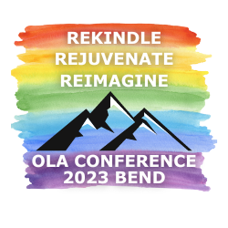

Notable speakers/sessions/activities:
- Andy Mangels
- Poison Waters
- Tribal History/Shared History: Inviting Indigenous voices into libraries
- Rethinking Dewey
- “Oh, No, We Went Viral”: Surviving Attention from Right-Wing Twitter
- In conversation groups: BIPOC, Special, Public, Academic & School
- Library Prom
- Expedition Happy reception
- CSD get connected activity

Notable awards/honorary memberships

2023 President’s Award: Roxanne Renteria (14:30)
President’s Accomplice Award: Arlene Weible (18:19)
Distinguished Service Award: Margaret Harmon-Myers
OLA Librarian of the Year: Crook County Library Staff (59:59)
Library Employees of the Year: Crook County Library Staff (59:59)
Library Supporters of the Year: Keith & Pepper Teem, Mt Angel Public Library
Library Supporter of the Year: Karen Salman, Springfield Public Library
Intellectual Freedom Champion Award: April Witteveen (6:01)
EDI Antiracism Recognition Award: Ericka Brunson-Rochette (21:25)
Evelyn Sibley Lampman Award (CSD): Rocío Espinoza-Cotero
Pearl Award (PLD): Dea Nowell

Legislative Activity

- OLA’s 2023 legislative agenda focused on School Libraries, Broadband and the State Library Budget.

- Library Legislative Day took place on February 15th, 2023 at the State Library of Oregon. 43 librarians joined OLA Lobbyist Tess Milio to speak with legislators to advocate for SB 885: E-Rate Consultant and Connecting Oregon Fund, SB 1075: Stronger Media Standards and More Teacher Librarians in K-12 Schools, Ready to Read Grants and the State Library budget. More than 30 legislators came to the State Library to pick out a book to donate to a library of their choice.

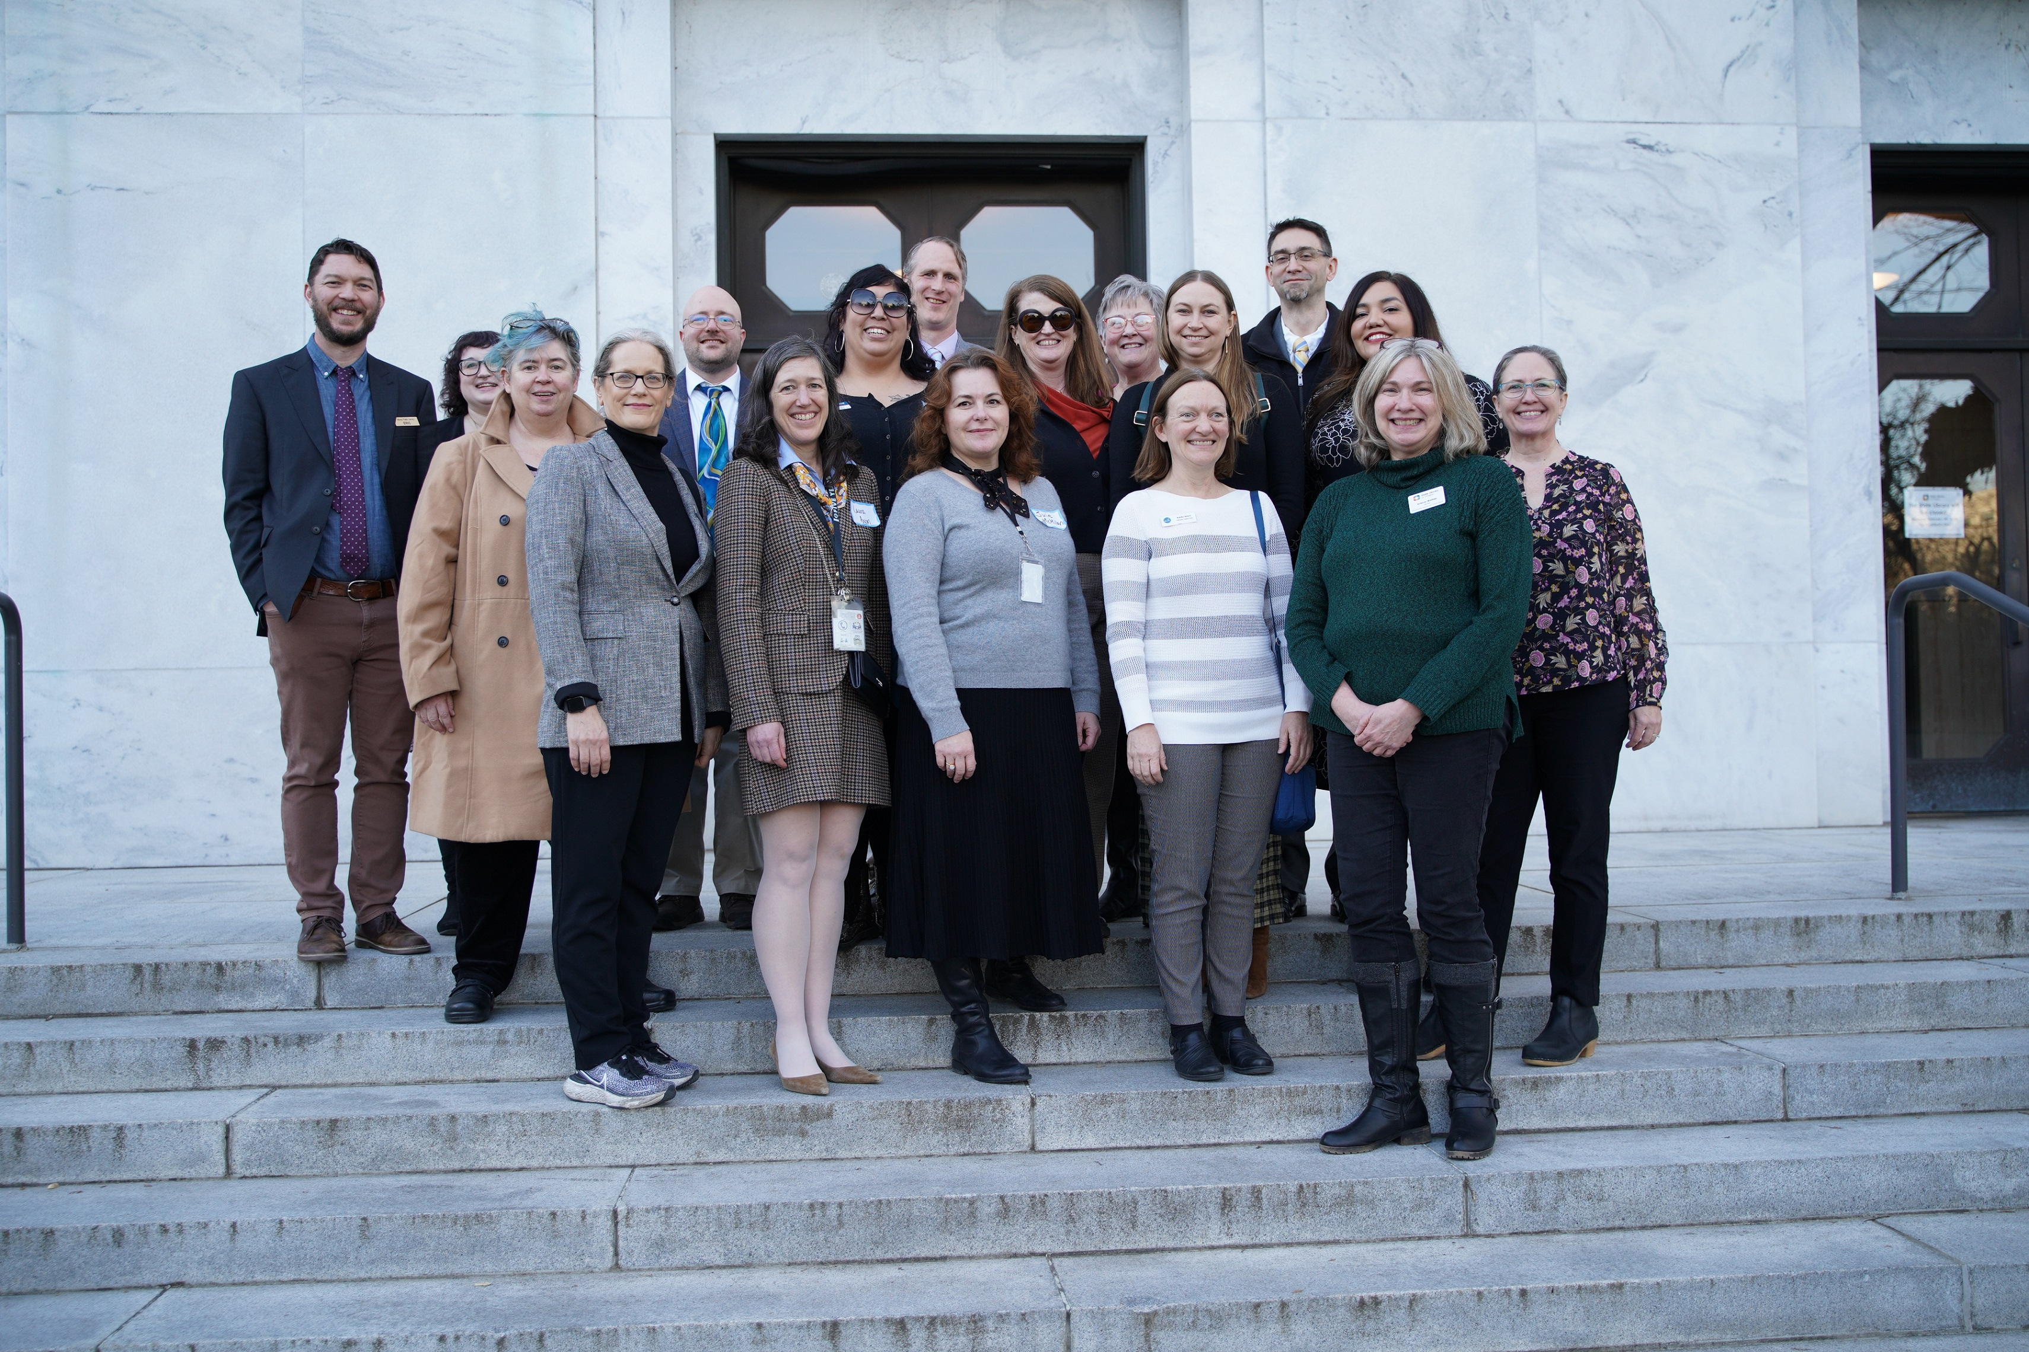

- Legislative Committee Co-Chairs Jeremy Skinner and Kim Olson-Charles, member Kari May and State Librarian Wendy Cornelisen testified in front of the Ways & Means Subcommittee on General Government on behalf of the State Library Budget.
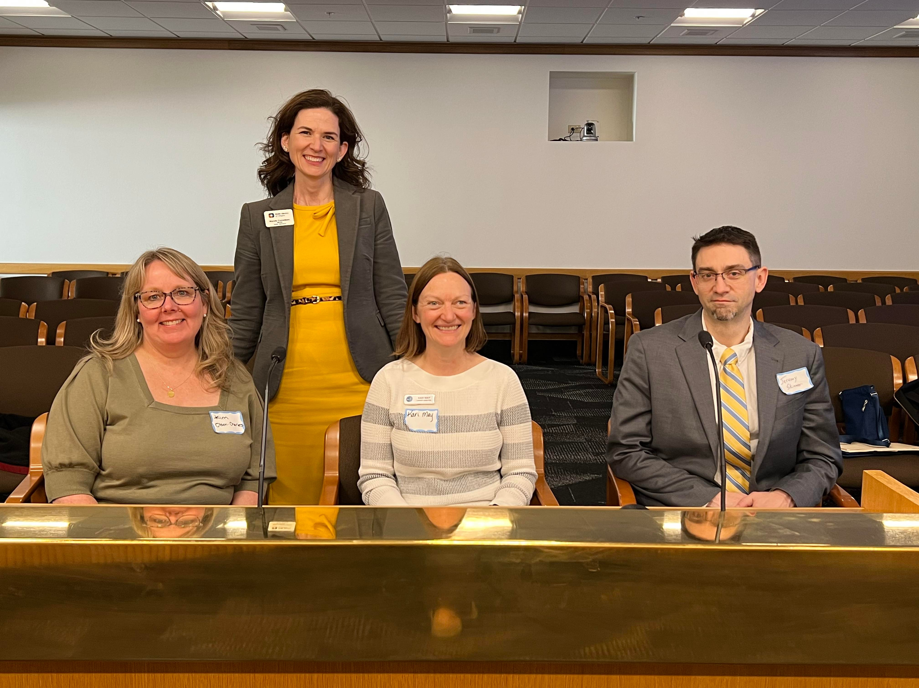

- They also continue to actively monitor the following:
  - HB2872A Dolly Parton Imagination Library
  - HB 3198 Early Literacy Funding
  - SB215 ODE technical fix bill
  - HB 3121 Textbook Affordability Program
  - Any bills that appear to change the processes and authority of school curriculum and other processes that could impact libraries.

- The committee issued the following statements of support:
  - HB 5512 Law Library Budget
  - The Faster Internet Oregon Initiative

- Advocacy Made Easy: OLA’s 2023 Legislative Agenda and What You Can Do to Help!, was presented by LC members at the OLA Conference

Unit Activity

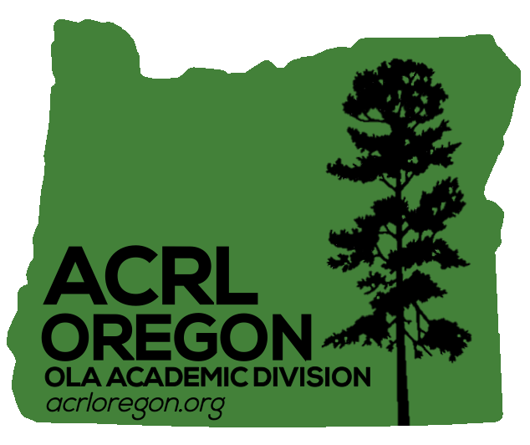
- ACRL-OR
  - They were unable to hold an in-person joint fall conference with ACRL-WA but in its place offered two virtual meetings for members to be able to come together and share. These sessions took place on October 28th and November 18th, 2022.
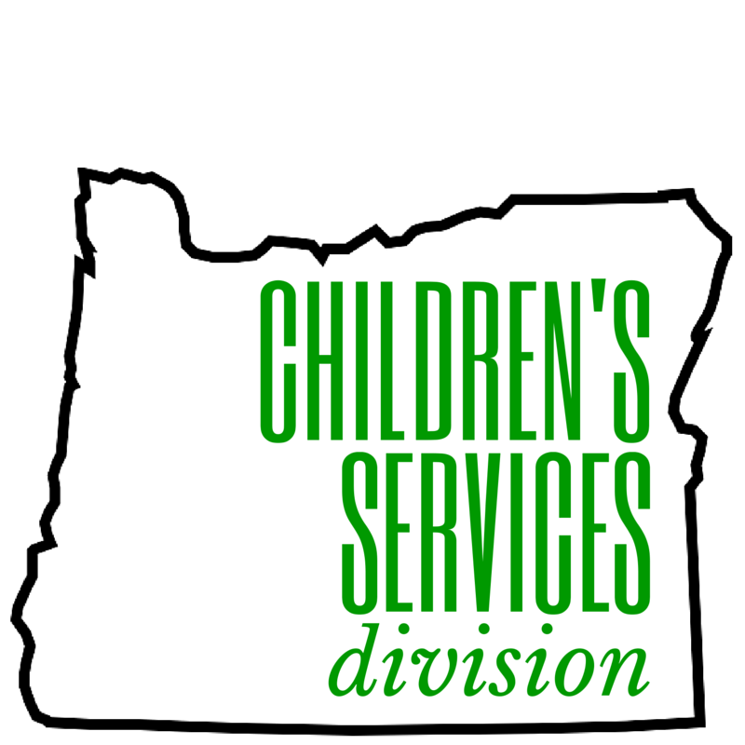
- CSD
  - They completely revitalized the Oregon Performers Directory, digitizing and organizing performer information, making the information more accessible to libraries across the State.
  - Co-sponsored the Tribal History/Shared History: Inviting Indigenous voices into libraries pre-conference
  - Their Book Buzz winter workshop was held on January 25th, 2023. Attendees gathered to talk about new and noteworthy youth books with a focus on diversity and inclusivity.

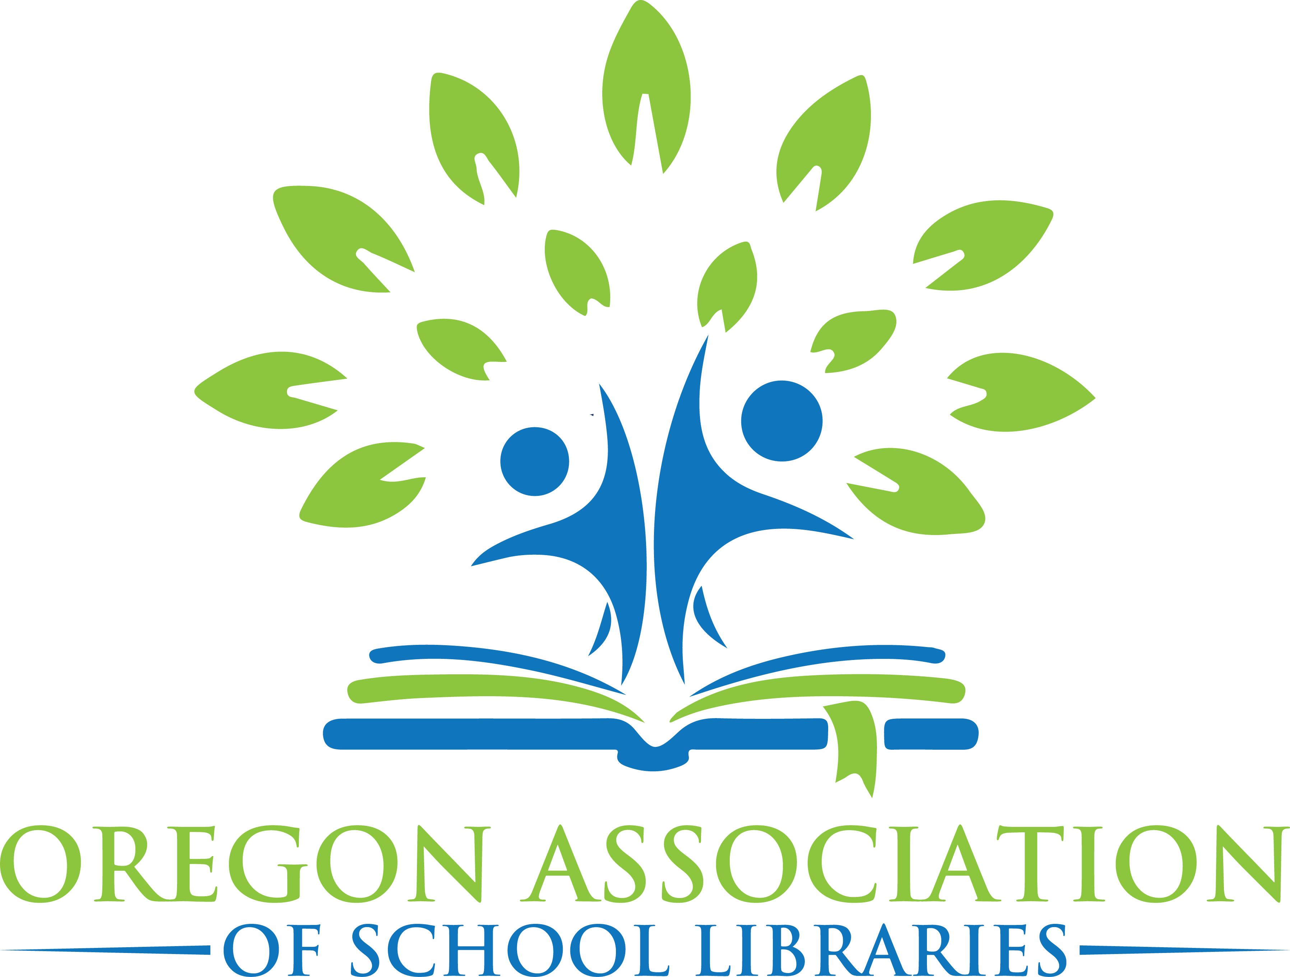
- OASL
  - Held their fall conference on October 15th, 2022 at Bend Senior High School in Bend, OR. The theme was Breakout of the Mold…Innovate…and look at old things in a new way!

  - OASL Teacher-Librarian / Library Media Specialist of the Year Award:
    - Carrie Light, lake Oswego School District
    - Tricia Snyder, Reynolds Middle School
    - Grace Butler, Whitman Elementary School

  - OASL Classified Library Staff of the Year
    - Gigi Michaels, Griffin Creek Elementary School

  - Honorary Life Membership Award
    - Susan Stone

  - The 2023 Beverly Cleary Children’s Choice Award winner is Peanut, Butter, and Crackers: Puppy Problems by Paige Braddock

  - OASL continues to organize the successful OBOB program for 3rd-12th grade students. This year’s winners are:
    - Elementary division: Hallinan
    - Middle School division: Winterhaven
    - High School division: Lakeridge

- OYAN
  - The 2023 Mock Printz workshop was held on January 14th, 2023. This year’s winner is All my Rage by Sabaa Tahir

  - 2023 OYEA winner
    - Kate Fischer, Teen Services Librarian with Crook County Library

  - They also released the 2023 Book Rave List of the best young adult fiction and non-fiction books released in 2022.

- PLD
  - The Winter Training UnConference took place on March 24, 2023 at Tigard Public Library. Guest speaker Meredith Farkas spoke about the assumptions, ideas, and structures, such as the cult of productivity and vocational awe, that need to be dismantled in order to build a better collective future in libraries.

  - They also launched their Expedition Happy fundraiser. Participants simply logged different wellness or health activities with each activity adding miles to their total, helping them progress through the 969-mile virtual challenge course. Throughout the challenge, participants made virtual stops at 11 public libraries in Oregon, learning more about each library’s history, collections, unique services, and more. The libraries on this year's inaugural route were: The State Library of Oregon, Salem Public Library, Molalla Public Library, Garden Home Community Library, Washington County Law Library, Athena Public Library, Baker County Library District, Crook County Library, Sweet Home Public Library, Coos Bay Public Library, and Curry Public Library.
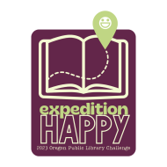

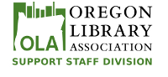
- SSD
  - The 27th Annual Support Staff Conference took place on July 20-21st in Ashland, Or. The theme was Find Our Way.
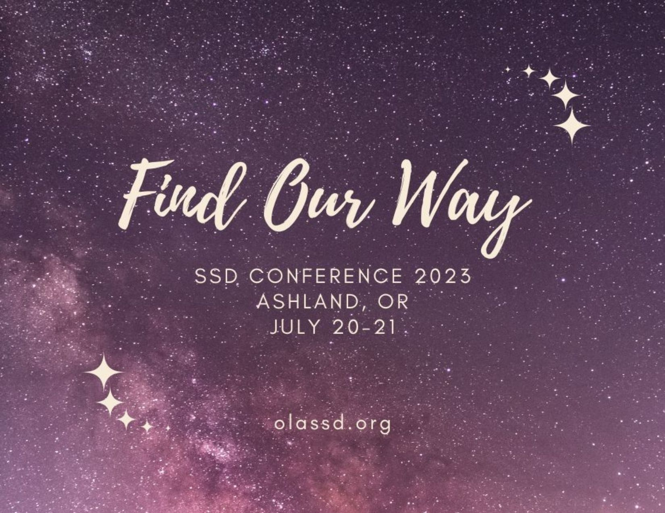

  - They also provided their popular Book Mending Workshop at the OLA Conference in Bend.

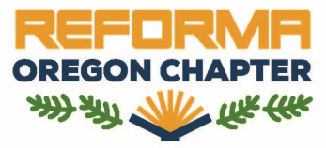
- REFORMA Oregon celebrated their first year as an official Division of the Oregon Library Association!

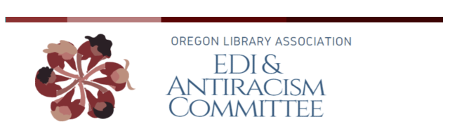
- EDI Anti-Racism Committee

  - The committee successfully released a full season of their Podcast Overdue: Weeding out Oppression in Libraries and has begun releasing a second season.
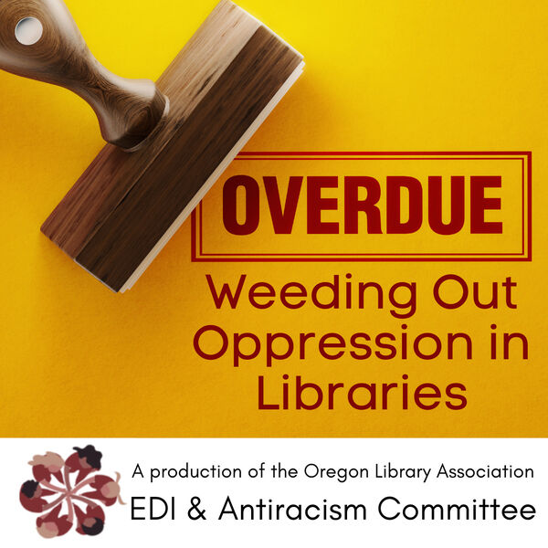
  - They’ve also responded to several requests from libraries around the State asking for guidance on how to incorporate more equitable, diverse, inclusive and anti-racists practices into policies, programming, collections and guidelines.

  - The EDIA committee released the following official statements:
    - Meaningful Support for BIPOC Library Workers
    - Condemning personnel cuts at Linn-Benton Community College

  - The OLA Board voted to make the Chair of the EDIA Committee a voting member of the Executive Board.

- IFC
  - IFC continues to respond to intellectual freedom issues by providing guidance and advocacy to libraries experiencing challenges around Oregon.

  - They’ve released the following statements:
    - Statement on Medford School District’s removal of The Handmaid’s Tale: Graphic Novel
    - Statement on Crook County Library Board Request for Inclusionary Treatment of LGBTQIA+ Library Materials
    - Statement regarding Intellectual Freedom and Materials Challenges

Leadership
- LIOLA 2023 took place at the Silver Falls Conference Center from July 23rd-25th. This year featured an all new curriculum taught by Christina Fuller-Gregory, one of Library Journal’s 2021 Movers & Shakers. Ten leaders and five mentors came together to build their strengths and look at leadership through an EDIA. The 2023 LIOLA cohort will continue to meet virtually throughout the year.

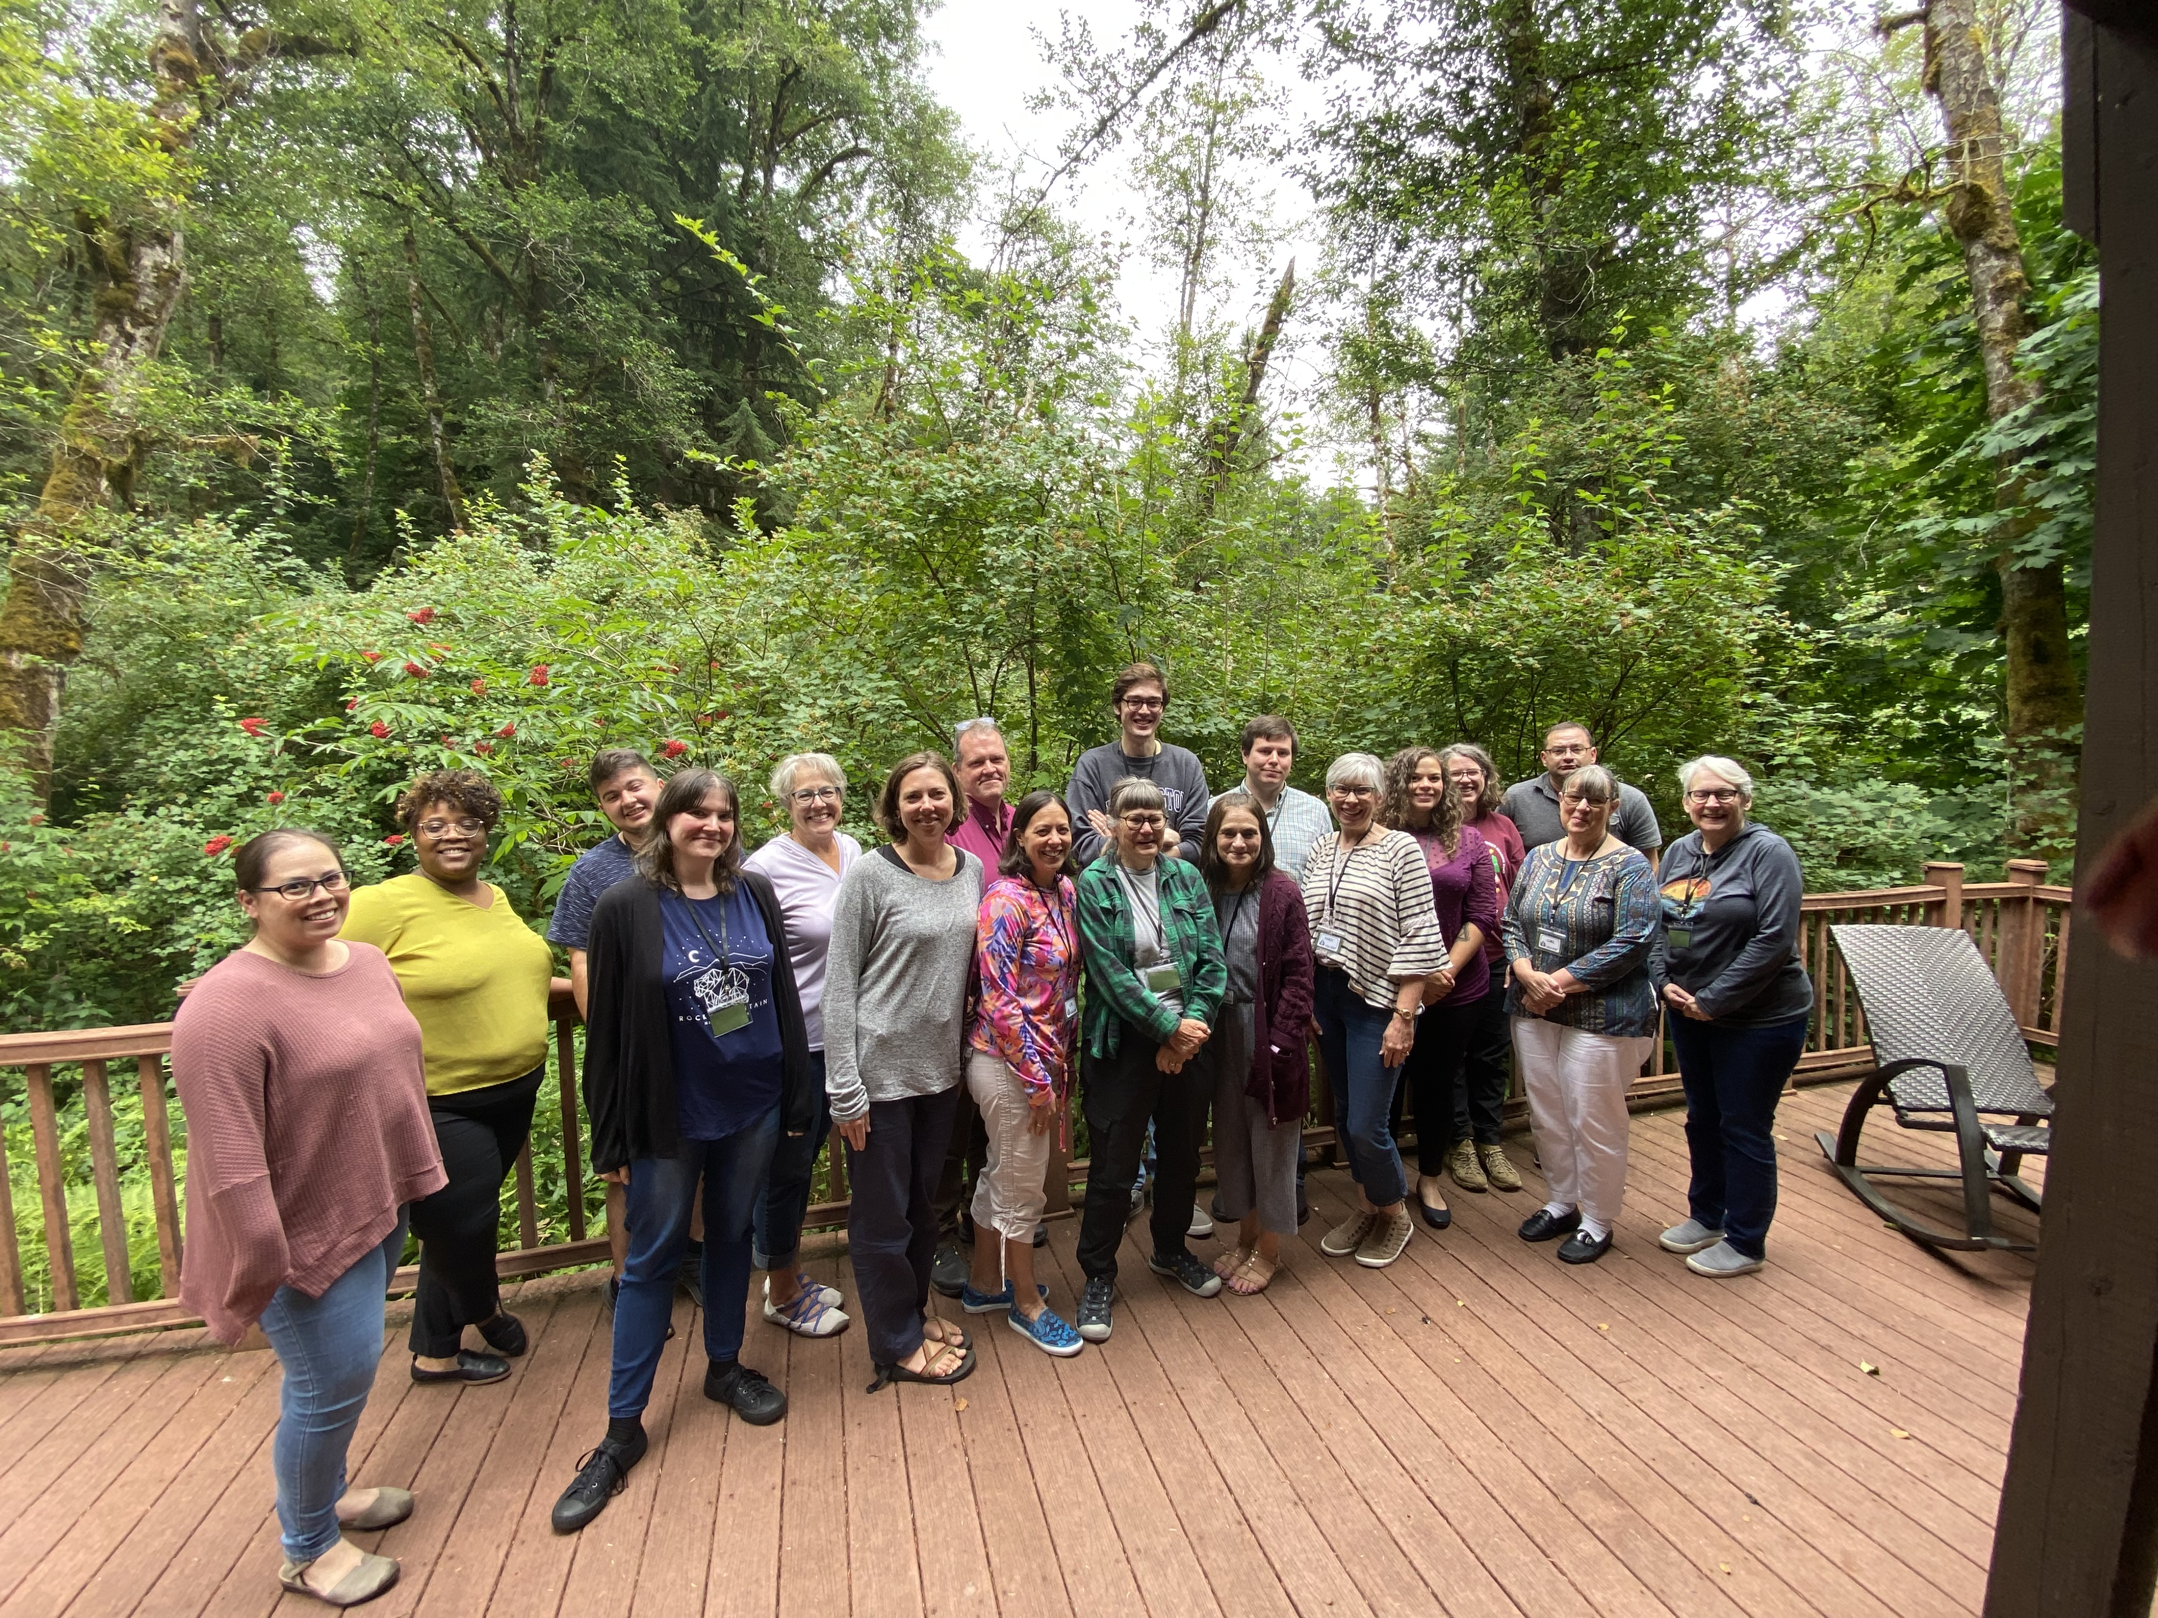

- Oregon Author’s
  - The Oregon Author’s Committee is back! They’ve relaunched their website with new features, information and a more user-friendly interface.

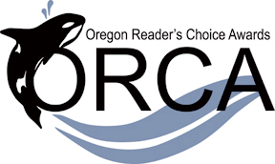
- ORCA
  - 2023 Winners:
    - 3rd-5th Grade Division: Measuring Up by Lily LaMotte
    - 6th-8th Grade Division: Snapdragon by Kat Leyh
    - 9th-12th Grade Division: Almost American Girl by Robin Ha

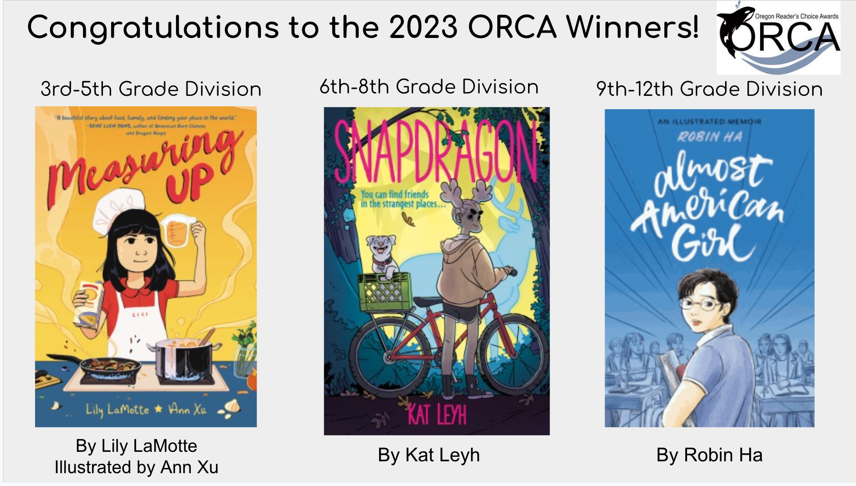

- Technical Services Round Table (TSRT)
  - In order to help facilitate work being done in libraries toward anti-racist, anti-oppressive librarianship, TRST has created a space for collaboration on working to select respectful and inclusive language in catalog records, including choosing language that people use to describe themselves through the OLA Critical Cataloging Repository

- Staff Training Round Table (STRT)
  - STRT released an online training titled “Make it Stick” full of tips and tricks on how to hold a successful training session.

This is just an overview of all the amazing work that OLA units and members have been working on. There is so much more being done that goes unnoticed or unrecognized. I would like to thank every single one of you for volunteering your time and sharing your skills with OLA. I acknowledge that the enrichment you all provide our organization often comes at great personal cost. It has been an honor to serve as your President this year. Thank you.

Respectfully submitted

Star Khan
Presidenta de la Asociación de Bibliotecas de Oregón 2022-2023

OLA Annual Reports 2021-22
Divisions, Committees, Round Tables, Special Assignments

OLA unit: Oregon Library Association
Name: Shirley Roberts, OLA Association Manager
Work or Primary Email: sroberts.ola@gmail.com

Identified Statistics.

1. Membership (as of 8/31/22) – these numbers will be added shortly
Total: 989
General: 851
Students: 71
Business/Institutions Partners Basic: 12
Business Partners Sustaining: 1
Institutions Sustaining: 16
Lifetime: 37
Prospects: 3,480

Unit Membership Breakdown (first recorded 2015-16 report):
Academic Division (ACRL_OR) 108
Children’s Services Division 109
Oregon Assn of School Libraries. 218
Oregon Young Adult Program. 95
Public Library Division. 169
REFORMA Oregon 68
Support Staff Division. 67

Documents Interest Group of Oregon. 12
International Relations Round Table. 18
Legal Reference Round Table. 13
Library Assessment Round Table 22
Library Instruction Round Table 30
New Member Round Table 78
Outreach Round Table 21
Past President’s Round Table 19
Reference Round Table 36
Staff Training Round Table. 48
Technical Services Round Table 51

2. Finance
General Fund - OLA
- Income: $93,094
- Expenditures: $96,567

- OLA Investments
DWM. -$99,889
Connected Wealth: -$13,656
OASL Investments
DWM Hull Endowment -$52,744
DWM Hull Earnings - $8,904.05
Connected Wealth. -$5,955

It was determined in December 2014 that certain statistics need to be included in the annual report.

It was requested that participation of OLA unit events be established and reported here in the Annual Report. Here are the events where participants registered through forms in Personify.

SSD Conference (July 2022 - onsite): 128
OASL Fall Conference (October 2021 - Virtual): 137
Oregon Battle of the Books (OBOB – hybrid): 488

