OLA Business Meeting
April 22, 2021
OLA Virtual Conference
Draft Notes

OLA Board Presenting: Kate Laskey, Arlene Weible, Lori Wamsley, Elaine Hirsch, Buzzy Neilsen, Jennifer Patterson, Star Khan, Shirley Roberts

Attendees Participating: 118

President Kate Lasky called the meeting to order

Welcome/State of the Organization.
Kate welcomed all in attendance. Thank you’s and acknowledgement given to the State Library of Oregon, OLA Administrator, and Conference Committee Chair and Members. An association update, or state of the organization was shared.

The association has been more focused on its advocacy work. Throughout 2020 and 2021, OLA worked intentionally to solidify its commitment to antiracism values and set its strategic direction to implement meaningful change within the organization. We have made strides in this work AND there is much more work to be done. Some evidence of action and advocacy this year include our:

· Statement Against Anti-Asian Violence, and,
· Statement in Response to Executive Order 13950, Former President Trump’s order to disallow diversity training. The was repealed on January 20 by President Biden; and,
· The association emphasizes on its value for and support of library workers with its Statement to Prioritize Library Workers in COVID Vaccine Distribution – representing our membership in a more inclusive and actionable way.

The association has benefited from the timely and courageous leadership by the EDI Antiracism Special Committee and their work to educate Oregon librarians, especially library managers, about the deeper and active meaning of Equity, Diversity, Inclusion, and Antiracism. Their Statement defines the meaning of these words and guide us to use them actively to manage change in our library community.

Membership Vote.
OLA Parliamentarian, Buzzy Neilsen presented the questions that are being voted on for further clarification. Polling was used to collect votes from OLA members. Here are the questions:

- Shall REFORMA Oregon become a division of OLA?
Star Khan spoke to this request, as submitted for consideration by REFORMA Oregon
- Should the OLA bylaws be amended to make the Equity, Diversity, Inclusion (EDI), and Antiracism Special Committee a permanent (i.e. standing) committee of OLA?
Kate Lasky spoke to this request, as submitted by the OLA Board.
- Should the OLA bylaws be amended to rename the “Honors, Awards, and Scholarships” Committee to the “Awards” Committee?
- Should the OLA membership be able to create new divisions via online vote?
- Should the minimum membership turnout requirement (i.e. quorum) for an online vote to amend the bylaws (currently 50% of the membership) be changed to match the turnout requirement for amending bylaws during a live meeting (currently 10% of the membership)

Treasurer’s Report
Lori Wamsley’s report on the financial state of the Organization. OLA, from a financial perspective, is a fiscally sound organization. Our financial report through March 31, 2021

Financial Information:
Total Assets: $ 1,064,419.98
Checking: $ 90,083.20
OLA Long-term Investments: $ 381,666.47
OLA/OASL Mid-term Investments: $311,948.27
OLA Scholarship: $ 23,750.39
OASL Hull Endowment: $ 169,209.44
OASL Hull Earnings: $ 79,034.29
OLA Budget 2020-2021
Income: $91,180
Membership Dues: $55,250 (47%)
Conference: $30,125 (25%)
Other Misc.: $5,805 (6%)
To make up the difference: Draw on Equity: $25,916
Expenses: $117,096
Association: $47,861 (41%)
Conference: $15,242 (13%)
Lobbying: $27,728 (24%)
Board/Affiliation/Committee: $26,264 (22%)

Members can always find more information about OLA’s financials at the OLA website: https://ola.memberclicks.net/financials

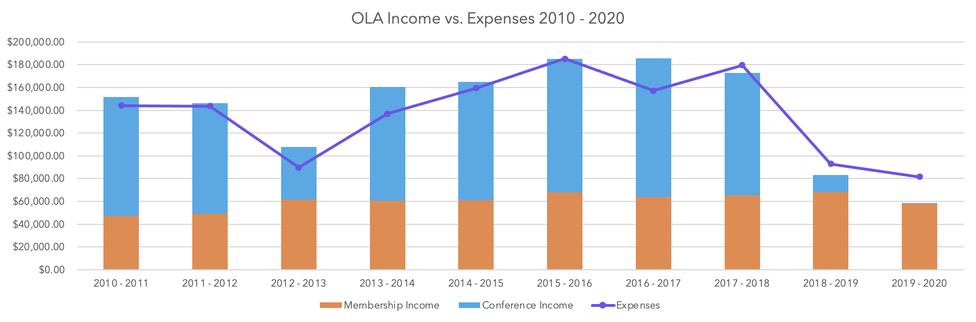
Financial Review:
- Conference Income
  - Board approved: 2020-2021 budget with a conference net income of: $15,000.
- Fundraising/Sponsorships/Donations
  - Separate committee to explore options in these areas.
- Long-term Investments
  - Board approved: Adding long-term investment distribution language to OLA’s bylaws. In December 2020, distribution of $11,502 was added to OLA’s general fund.
- Membership Dues
  - Have not changed since pre-2010, yet OLA expenses have gradually increased in that time. Recommended: 1) membership dues increase of 2% every 2 years, 2) expansion of upper salary ranges, and 3) a quarterly payment option for members.
  - Board approved: 1) In June 2020, quarterly payment option (currently available). 2) In October 2020, 2% increase in dues every two years, beginning September 2021.

September 1 – August 31 | 2020-2021 | 2021-23 | 2023-25
 | Current | 2% increase | 2% increase
Salary up to $20,000 | $30.00 | $30.60 | $31.21
Salary $20,001 - $25,000 | $45.00 | $45.90 | $46.82
Salary $25,001 - $30,000 | $50.00 | $51.00 | $52.02
Salary $30,001 - $35,000 | $60.00 | $61.20 | $62.42
Salary $35,001 - $40,000 | $70.00 | $71.40 | $72.83
Salary $40,001 - $45,000 | $75.00 | $76.50 | $78.03
Salary $45,001 - $50,000 | $85.00 | $86.70 | $88.43
Salary $50,000 - $60,000 | $90.00 | $91.80 | $93.64
Salary $60,001 - $70,000 | $100.00 | $102.00 | $104.04
Salary $70,001 and over | $120.00 | $122.40 | $124.85

Next steps:
An increase in membership dues require a membership vote to ratify the Board’s approval. Voting on the 2% increase in membership dues every two years will be part of the election of OLA officers. Please vote!

OLA Election
Elaine Hirsch announced the candidates for the following OLA officer positions:

Secretary (term 2021_2022):
Star Khan, Driftwood Public Library
Max Robinson, Emporia State University

Treasurer (term 2021-2023):
Stuart Levy, Parkrose High School
Karen Muller, Hillsboro Public Library

President Elect/President/Past President (term 2021-2024):
Marci Ramiro-Jenkins, McMinnville Public Library
Jerianne Thompson, Tualatin Public Library

Ballot will be emailed to members in early May. You will have an opportunity to hear from Marci and Jerianne through a pre-recorded message that will be included with information on all the candidates.

State Librarian Report
Jennifer Patterson acknowledged the efforts of library workers during this past year and thanked them for their creativity and unwavering commitment to providing vital services to their communities during the pandemic.

Jennifer expressed gratitude for the ongoing partnership that the State Library has with the Oregon Library Association. Opportunities to collaborate during this past year included:
- LSTA funding to support the OLA conference
- Support for the EDI and Antiracism Toolkit
- Collaboration with OASL on OSLIS
- OLA Quarterly issue featuring the State Library

Jennifer provided some State Library updates including:
- Information about the American Rescue Plan Act funding received by the State Library
- Library workers continuing education needs assessment
- Talking Book and Braille Library update
- State Library Digital Collections
Honoring Past President, Elaine Hirsch
Kate recognized Elaine Hirsh for her time as President of OLA for the 2019-2020 organization year. Elaine shared the plaque she had received in honor of that recognition.

Incoming President Remarks
Arlene informed the attendees that during 2021-22 there will be no OLA conference. We will have the REFORMA national conference virtually in November 2021, hosted by our Oregon REFORMA chapter and the national Public Library Association (PLA) conference in Portland in March 2022. OLA units will continue to provide the great programing and learning events throughout the year. The annual conference will return in April 2023, when we will go to Bend and celebrate our ability to meet again in person.

Even without an annual conference, Arlene provided a theme to help guide OLA’s efforts in the upcoming year: Doing the Work: Learn, Reflect, and Act.

Please contact Arlene if you are interested in getting involved in OLA.

Voting Results
OLA Members 4/22/21: 941
Votes cast: 101
1: Shall REFORMA Oregon become a division of OLA?
Yes 95 / No 1 / Abstained 5
2: Should the OLA bylaws be amended to make the Equity, Diversity, Inclusion (EDI), and Antiracism Special Committee a permanent (i.e. standing) committee of OLA?
Yes 98 / No 1 / Abstained 2
3: Should the OLA bylaws be amended to rename the “Honors, Awards, and Scholarships” Committee to the “Awards” Committee?
Yes 90 / No 3 / Abstained 8

4: Should the OLA membership be able to create new divisions via online vote?
Yes 96 / No 1 / Abstained 4

5: Should the minimum membership turnout requirement (i.e. quorum) for an online vote to amend the bylaws (currently 50% of the membership) be changed to match the turnout requirement for amending bylaws during a live meeting (currently 10% of the membership)
Yes 82 / No 11 / Abstained 8

Conference Committee Chair:
Lacey Legel reminded everyone about the extended conference access through Aug 31st. Lacey gave some history of the conference planning, thanked the 2020 conference committee for their work and then recognized each of the 2021 conference committee members. Lacey noted that 12 of our 21 committee members were new OLA volunteers and expounded on the benefits of volunteership within the association. Lacey thanked the state library, the sponsors and exhibitors and our attendees & reminded everyone of upcoming opportunities to win prizes during the conference & of the special events still remaining during the conference.

Adjourn.
Kate thanked all that took time to be present for the annual OLA Business Meeting and adjourned the meeting.

