CSD Spring Workshop 2016 Notes:

Interactive activity stations made up the bulk of the workshops, with attendees getting LOTS of hands-on experience and fantastic ideas for programs running the gamut from crafts to Screentime Awareness Week celebrations to STEM activities:
- Sign Language Storytime - incorporating sign language into storytime with Dawn Prochovnic. Dawn was inspired by her presentation at our workshop, and she wrote up a blog post with a bunch of links that will be helpful to anyone wanting to incorporate sign language into library programming!
  - 26 Ways to use sign language in storytime
  - And she is always open to answering questions by email at dawnp@smalltalklearning.com
- Bubble-making - grade school science fun with Violeta Garza of Multnomah County Library
- Island Dreams - no screentime celebration complete with tons of activity station ideas from Mary Beth Hustoles and Jessica Marie of Salem Public Library
- Tinker Tech - with Lucinda Gustavson of Springfield Public Library
- Marble Runs - STEM with Carson Mischel and Lizzy Lowery of Beaverton City Library
- Calming Jars - with Kathy Street of Oregon Trail Library District

We also had a short report from OLA President Jane Corry:
- OLA hired a contractor to help develop a strategic plan.
- They will be doing focus groups happening in several locations around the state - contact Jane if you are interested in more information.
- There will be a survey coming out soon on multiple listservs so PLEASE FILL IT OUT and share where you’d like to see OLA go!

Representatives from See to Read shared info on doing preschool eye checks:
- At least 15% of preschoolers have undetected vision problems that can be easily solved with glasses, and a 2014 House Bill mandates all children have a vision screening before entering public school.
- See to Read is a community partnership between OAPL, oregon Elks, and Oregon Lions to administer free vision screenings at public libraries for children ages 3-7.
  - The only equipment needed is a room to do screenings in and two chairs.
  - The test is the equivalent of taking a snapshot of the children’s eyes. 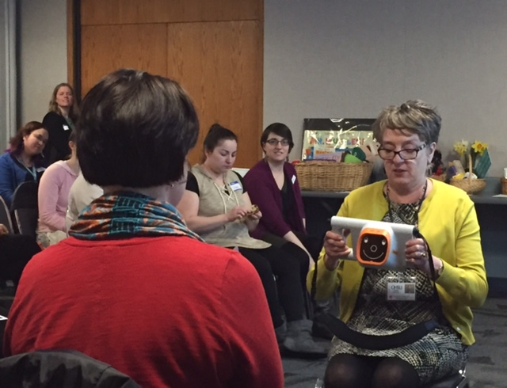
  - They can do screenings at community events, not just at public libraries, provided the event is not in sunlight (natural light can impact the screening).
  - The program is open to all public libraries around the state, and they especially focus on regions outside the Willamette Valley in the summer and early fall months. They recommend scheduling annual screenings.

To request an event, please contact Bethany at 503-545-8114 or painterb@ohsu.edu.

Katie Anderson shared Oregon State Library updates on Oregon-wide initiatives (see the Spring 2016 CSD Board meeting minutes for a complete recap). Topics covered include:
- Katie has developed tools for partnering with Early Learning Hubs; they are available on the CSD website under the Took Kit heading..
- Summer Reading listserv - only one person per library is on it.
- SR certificates - over 11,000 were printed and given out in 2015!
- Summer Reading Sweepstakes from Oregon College Savings Plan - 2016 theme is “On your mark, get set...save!” They also sponsor one free Summer Reading program for Oregon libraries serving populations under 10,000 (that’s 58% of us!)!
- OregonASK is offering support for school libraries to be Summer Learning, Library, and Lunch (SL3) sites. If you are interested in partnering with a school library for this, contact Katie Anderson and she’ll get you the info.
- Ready to Read grant applications will be sent to eligible libraries in early July are due back AUGUST 31ST (same as always!).
- Open e-Book - look through the kidslib listserv archive if you hadn’t seen the emails from Katie, or find out more on the Open e-Book site. eRate grants cover a wifi hotspot if you want to promote this on outreach (lots of hoops to jump through since it is federal funds, but it’s an option).
- Focus Institute will be September 25-28 at Menucha
- National Park System is celebrating a birthday, so all 4th graders can get into all National Parks for free during the 2016 calendar year. You can get more info at Every Kid in a Park, including how to download the free pass.

Barratt Miller (Oregon City Library) shared a CSD update.
- CSLP update (Collaborative Summer Library Program
  - Manual options are changing - more info after the April CSLP meeting.
- 2017 theme is all-ages - Build a Better World
  - Early childhood art done by David Macaulay
  - Teen and adult art done by Upstart artists
- Early literacy calendar (now titled Early Learning Activities )is available - download it from CSD’s Tool Kit - Early Literacy page now! REFORMA roundtable is working on translating it into Spanish, hopefully done for 2017.
- Mock Belpre event was a hit and will now be an annual event sponsored by REFORMA!
- Revised draft of children’s services guidelines should be done later this spring.
- Preview of CSD in the next year:
  - Virtual Storytime Shares will be offered three times per year, starting in the fall.
  - Step Into Storytime preconference at OLA Conference is happening! There are also some conference sessions that will be of high interest to youth services folks, and Jane promised the President’s Party will be a lot of fun.
  - Fall workshop will focus on Summer Reading to help as you start planning for 2017!
  - The CSD-sponsored Mock workshop in December/January will be a Mock Caldecott
  - OLA Conference 2017 has an exciting addition - a big author event, probably the Friday night of the conference!!! OASL conference will be happening on Saturday. Public and school librarians are encouraged to attend sessions on Friday and Saturday.

